Sommario

01_INTRODUCTION 3

Introduction to the UNIX shell 3

CLI 3

File system, disks and partitions 3

File ownership and permissions 4

Filename and extension 4

Some basic bash commands 4

Pipes 5

02_REVIEWING FUNDAMENTALS OF PROGRAMMING 6

Programming and coding 6

Python 6

Conditional execution 6

Functions and routines 7

Libraries 7

DRY principle 7

Iterations 8

Data structures 8

**i.** **Strings** 8

**ii.** **Lists** 9

**iii.** **Tuples** 10

**iv.** **Dictionaries (maps)** 10

**v.** **Objects** 10

IPython shell 10

03_VERSION CONTROL 12

Correctness, replicability (and reproducibility), auditing 12

Distributed Version control and Code Source Management 12

The idea behind git 12

Using Git 13

**Io che provo a capire cose** 16

04_TESTING 18

Purity of functions 18

Types of test 18

Strategies of testing 18

i. **Informal testing** 18

**ii.** **Unit testing (anecdotal testing)** 19

**iii.** **Property testing** 20

(Some) Patterns of properties to be tested 22

Test driven development 22

Cellular Automaton: rule 30 23

05_LOGGING AND DEBUGGING 24

Debugging 24

*Breakpoints* 25

Assertions 25

Warning systems 28

Linters 28

Static type checking 29

06_VECTORIZATION 30

Precision (Floating point numbers) 30

Accuracy 32

Speed 32

NumPy - Numerical Python 32

Create an array 33

Operations between arrays and scalars 34

Random number generation 36

Some useful functions 36

Broadcasting 38

Directional application of functions 38

Memory recycling 39

Numpy for scientific data 39

Structured array 40

07_SCIENTIFIC COMPUTATION LIBRARIES 41

Scipy 41

Matplotlib 41

Multiple figures and customization 42

Linear Algebra – LinAlg (in scipy) 42

Eigenvalues and eigenvectors 42

Sympy 43

Differential equations (in scipy) 44

Fitting of a curve (in scipy) 45

Metropolis Algorithm 45

08_DATA PIPELINE AND SNAKEMAKE 47

Data types 47

• Text data 47

• Binary formats 49

09_DATAFRAMES IN PANDAS 50

Tidy Data 50

Introduction to Pandas 50

Series 51

Series as elements of a DataFrame 53

Dataframe manipulation 55

DataFrame visualization 57

10_OBJECT ORIENTED PROGRAMMING IN PYTHON 60

# **01_INTRODUCTION**

(See the beginning of the slides for some basic examples with Python)

## **Introduction to the UNIX shell**

The most commonly used shell is called **bash** (a very similar shell is present in OSX, and is possible to install it under window activating the Windows Subsystem for Linux option in the control panel.)

The bash is a type of shell. **shells** are interactive systems that take user input in the form of text commands and perform actions based on them. Most systems in a computer provide a shell interface, for example:

* bash: a shell of the operating system
* IPython: a shell to interface to a python engine
* most databases will provide one

Graphical User Interfaces (GUI) are useful, but they are no always available in all the systems (no in servers for example).

Command Line Interfaces (CLI) give you a faster, more reliable way to perform your tasks (most programs provide one, such as: firefox, openoffice, vlc.)

The commands:

can be given **interactively**, by actually typing each command, or using a **script**, where the commands are pre-written and get executed one command at the time.

For all intent and purposes, bash scripts can be used a program. As a matter of fact, big chucks of unix systems are just a collection of bash scripts. They can also be used to glue together various programs that provide a CLI.

## **CLI**

Command line interfaces of programs allows automation of work. One does not need to remember and perform the exact sequence of action each time they want to perform the same task, but might save the relevant command on a small bash script and execute it directly. This also allows batch execution, i.e. repeat the same task on a (potentially huge) number of files all at the same time. (For example, this converts all the JPG images in the current directory into GIF thumbnails in a "thumbs" sub-directory: mogrify -format gif -path thumbs -thumbnail 100x100 *.jpg). The same process with GUI tools would require 7 steps.

## **File system, disks and partitions**

The **file system** is the way that the operating system uses to organize the files in your **disk**.

It traditionally organizes the files in various directories. It can merge the content of various local disks (and remote ones) in a transparent way. The location of a file (or a directory) is represented with a string, where the **/** is used to separate between directories. Most programming languages (including Python) follow this convention (note windows uses \ to separate directory).

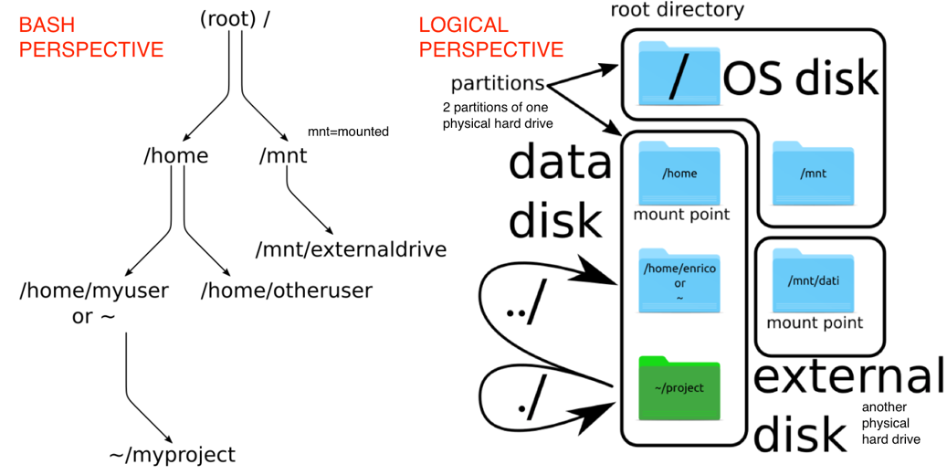

**../** used to refer to the same directory I am working currently

**./** used to refer to the directory on top

## **File ownership and permissions**

Each file is owned by a user, and a group (of which the owner usually is part of, but not necessarily).

every time a user wants to interact with the file, the permissions are given based on:

is it the owner? Or if not, does it belong to the group? Or anybody else

The permission are related to:

**reading**  **writing**  **executing** (or **entering** for directories)

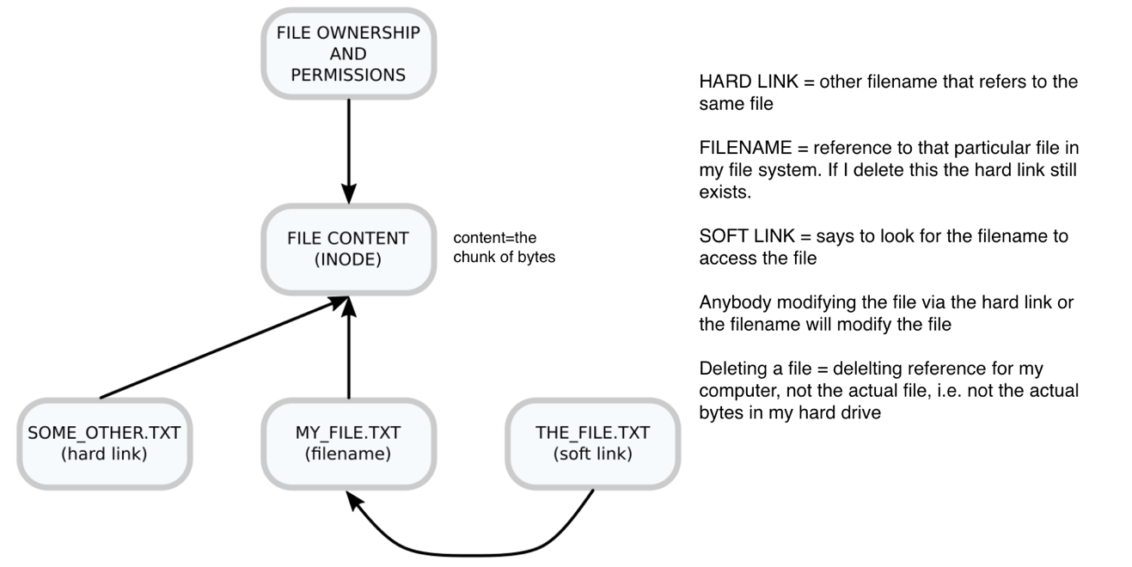

## **Filename and extension**

by tradition, file names end with a full stop and 3 (or more) letters, that are used to quickly identify what kind of file it is.

Some common extensions are:

.exe windows executable

.sh bash script

.txt raw text files

.doc, .docx Office Word files

.gif, .png, .jpg image files

The reality is that there is no rule linking the content of a file to its extension: you could rename a jpg image as a txt file, but the content would still just be the previous image. So extensions are actually meaningless, but are a way to guide the computer in interpreting the file.

## **Some basic bash commands**

Bash comes with a long list of pre-installed programs that provide several utilities. The ones that are (for our purpose) most important are the ones that allow you to move around and manipulate the file system and the files inside it

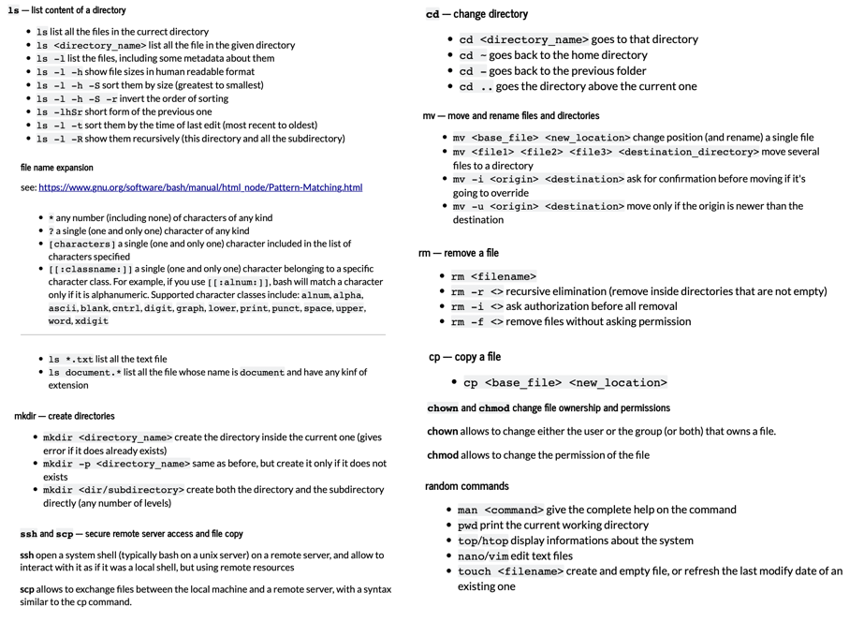

## **Pipes**

Pipes are a method of the bash shell that allows to manage the flow of the data inside and outside of a program, and between programs.

Any program has various "streams":

STDIN (0) - Standard input (data fed into the program)

STDOUT (1) - Standard output (data printed by the program, defaults to the terminal)

STDERR (2) - Standard error (for error messages, also defaults to the terminal)

Each one of these can be redirected to other places. The basic redirection is done with the > and < operators.

Input redirection

a program that takes parameters as text input from the user can be automated by passing it a file containing the input.

myprogram < input_file.txt

Output redirection

create (or overwrite) a file with all the output of the program

myprogram > all_output_file.txt

append (do not replace) the existing file with the output (good for logging)

myprogram >> all_output_file.txt

redirecting separately standard output and standard error streams

myprogram 1> regular_output_file.txt 2> error_output_file.txt

Piping to other programs

the | (pipe) allows to take the output of a program and use it directly as the input of another, without creating intermediate files.

ls *.txt | head -3 lists all the .txt files, shows only the first 3

# **02_REVIEWING FUNDAMENTALS OF PROGRAMMING**

## **Programming and coding**

These two concepts are often mixed up. We could use these two informal descriptions:

**Programming** is about thinking how to formalize a certain sequence of operation.

**Coding** is writing a computer program that actually performs the operations we have in mind.

While coding is strictly related to a specific programming language, most of the programming skills are identical among different languages. Actually, one does not even need a computer to be able to "program".

programming concepts

There are really only 5 basic concepts to programming; anything else, in all languages, is basically just rehashing of these ideas:

storing and retrieving things

conditional execution

functions and routines

iteration

data structure(s)

## **Python**

Python is a high level and interpreted language.

**High level** means that it tries to express its concepts in a way closer to the human than to the machine.

**Interpreted** means that it does not execute directly on the machine, but generates commands for the python interpreter, that executes them.

For sake of completeness, it's also a dynamically typed language.

Remember: spaces and tabs DO MATTER!

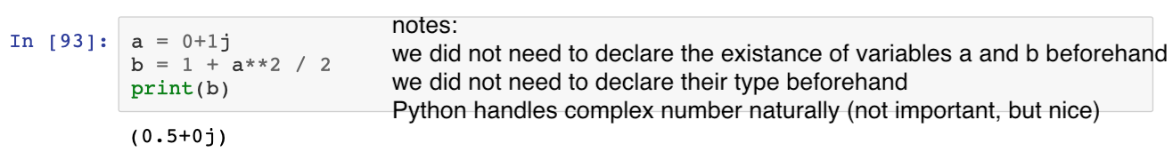

-If I now ask (in the terminal) type(a)it tells me complex, but formally I am asking the type of what is contained in a.

-Even if I did not need to declare the type of the variable, they are strongly type and Python will not do any under the hood conversions unless it is very sure of it i.e. user told it how to do that.

-Phyton will complain if I make an error, it will not try to guess what I want (like Java does when I try to add an int and a string for example)

## **Conditional execution**

i.e. do something only if a certain condition is met

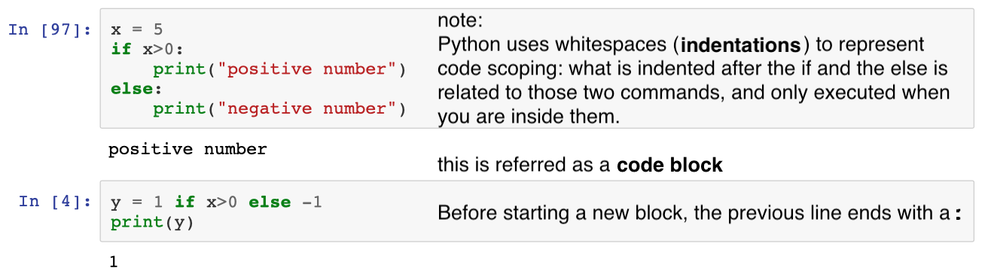

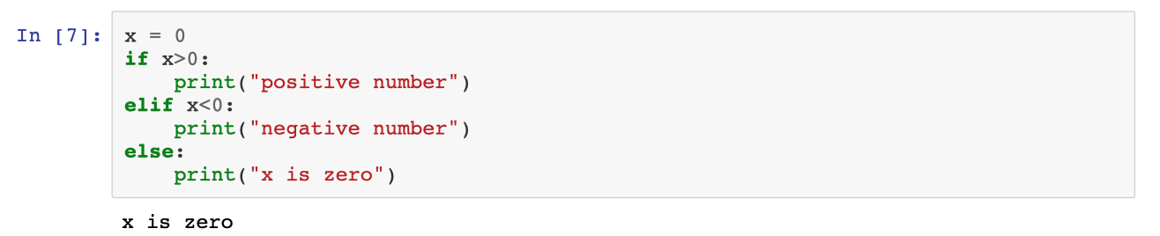

## **Functions and routines**

From the language perspective of Python they are the same thing, but from a conceptual perspective, they are very different (so try not to mix them):

**Routines** do something to the system, and usually don't return anything interesting (like printing).

**Functions** create new objects from the inputs, but don't modify the input themselves.

They are both referred as functions, and can do both, but try to know which is which and plan accordingly and try to avoid mixing the two.

def is the key word for defining a function; it is followed by the function name and the name of the parameters that the function takes, in parenthesis.

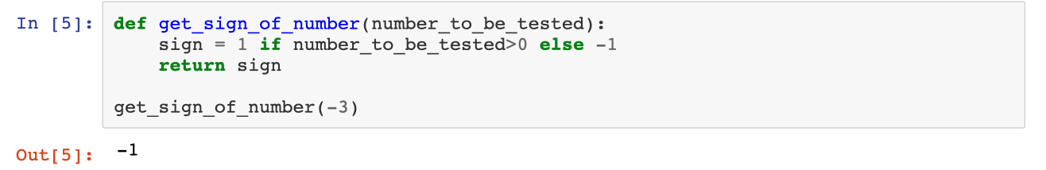

An important concept related to functions is the concept of **scoping**: when we execute a function, we can use variables that are reserved to the function; this allows to write simpler code.

Global variable: global var_name. I can define it even inside a function and initialize it later. Any modification that I make to it, will be seen globally (try to avoid global variables).

## **Libraries**

**Libraries** are collections of functions and classes that allow to reuse well-written code (from you or from somebody else) in your new code. There are several ways to import a library.

(import * imports everything it finds and causes a lot of bugs)

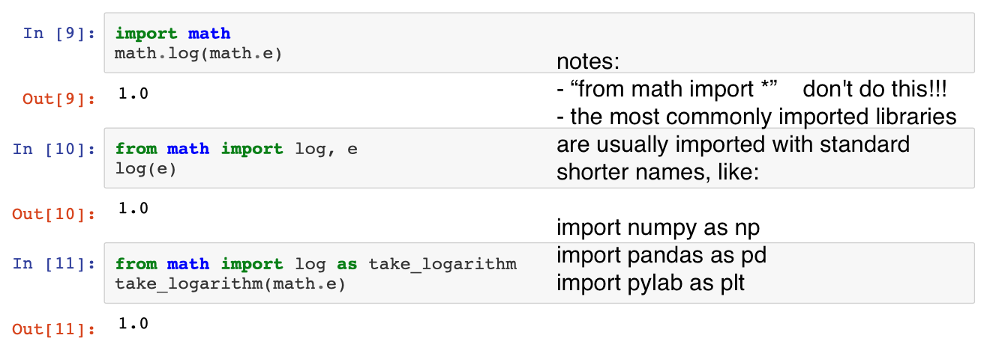

## **DRY principle**

**DRY**: Do not Repeat Yourself.

Repeating code (or copy pasting it) can lead to sever errors: dependencies on surrounding code; forgetting to change a variable name; visual clutter. Functions are the primary way of implementing DRY principles.

If you are going to do it more than twice (or even once) write a function instead.

## **Iterations**

Repeating an operation over and over, typically with a different input each time, or with an exit condition.

Usually they underpin the usage of words like: **while**, **for**/**for each**, **until**.

There are two main approaches to iteration: bounded and unbounded.

In the **bounded** kind of iteration, the program has an idea on how many iteration cycles it will need. It usually corresponds to saying: *for every one of these objects, do this.*

The **unbounded** iterations are more related to exploration. The program has no idea beforehand on how many steps might be necessary. It usually corresponds to saying: *do this thing until something happens.*

Unbounded iterations usually require some form of internal state that is used to perform decisions to continue based on what has been seen.

In python, bounded iterations are represented with a **for**, whereas unbounded with a **while**.

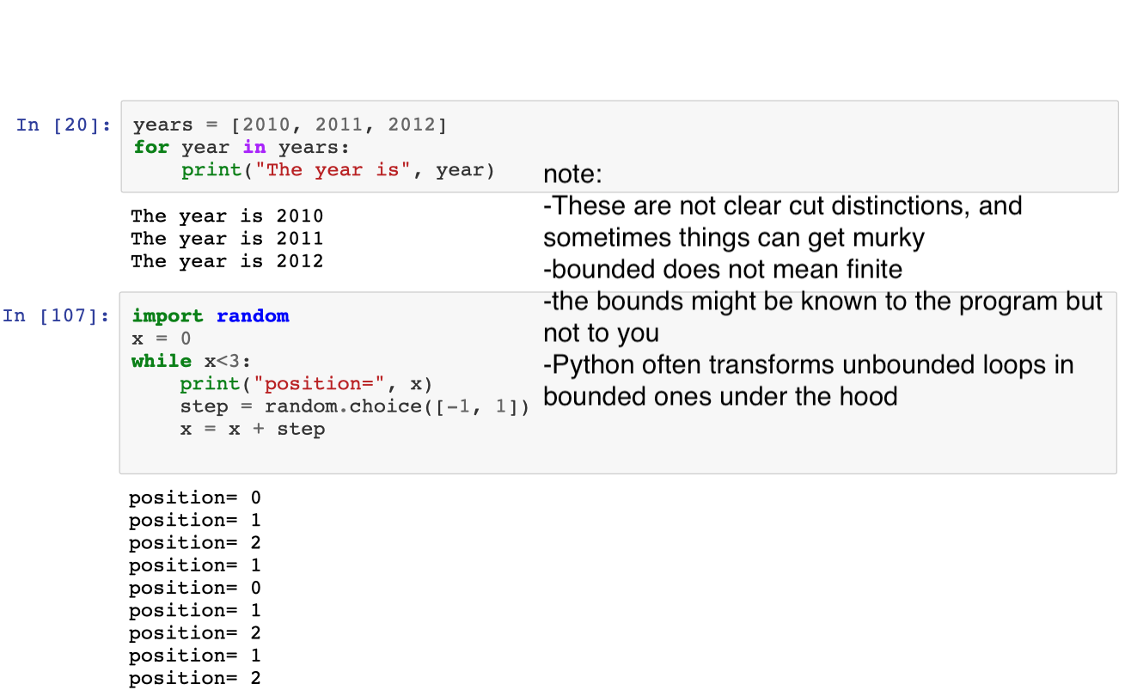

-In this program with while, I do not know how many iterations my program is going to make.

(From Python 3.6 the variable does not necessarily exist only inside the scope, be careful)

## **Data structures**

**Data structures** are containers that hold the information and make more or less easy to retrieve and manipulate this information. **Programming** can be described as creating and modifying data structures with the previous concept until the desired result is obtained. There is a great number of data structures, and more get introduced in a language by libraries.

Basics:

strings list tuples dictionaries (maps)

More advanced:

objects enum

Fundamental structures:

### **Strings**

Strings contain text and allow for some (relatively) complex manipulation of it.

Strings can be enclosed in single quotes, double quotes, triple single and triple double.

"text to be used" 'text to be used' '''text to be used''' """text to be used"""

single or double quotes are identical, triple quotes (both single and double) can span several lines

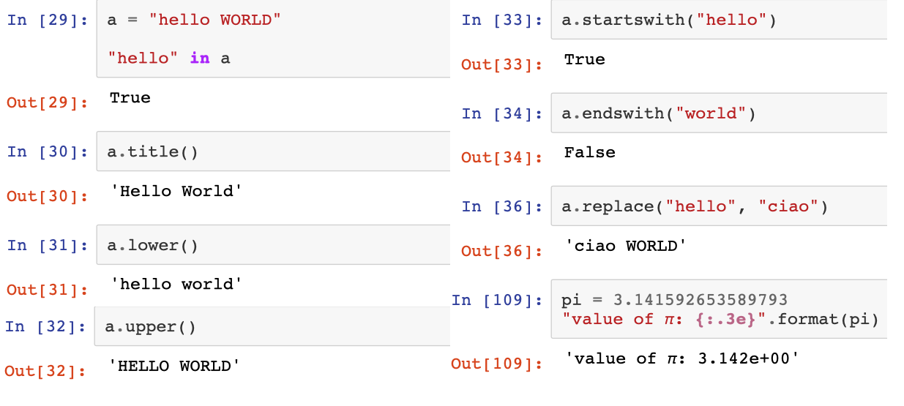

special characters:

by default, special characters that cannot be rendered directly are represented with \ followed by some letters or codes that uniquely identify them:

**\n** newline **\t** tabulation \U0001f604 unicode smiley face ( print(‘\codice’) )

it can recognize the whole unicode point name:

print('\N{grinning face with smiling eyes}') 😁

print('\N{GREEK SMALL LETTER ALPHA}') α

print("α") α

Indexing of objects

Several object in python allow to extract subsequences by using the **indexing operator [].**

Strings, lists ad most other iterable objects use 0-based indexing.

it is also possible to specify **ranges**, with a start and stop positions (assumed by default to be the first and last element). In a range the last element indicated is excluded from the sequence.

It is also possible to specify a **step**, that indicates if it has to skip some elements of the sequence.

* The generic syntax is sequence_name[ start : end : stepsize]

a = "hello world" ranges: steps:

Input: a[0] a[-1] a[:5] a[-5:] a[:5] + a[5:] == a a[::2] a[::-1]

Output: 'h' 'd' 'hello' 'world' True 'hlowrd' 'dlrow olleh'

### **Lists**

Lists are collections of items with some common characteristic. The typical usage is to store objects on which you want to perform some specific operation. The only restriction on the kind of objects you can keep in a list is thatthis operation is allowed on the data contained.

* The generic syntax is list_name[element1, element2, element3]

[1, 2, 3] is a list of integer numbers ['hello', 'world'] is a list of strings ['hello', 1, 'world'] is a list of generic python objects

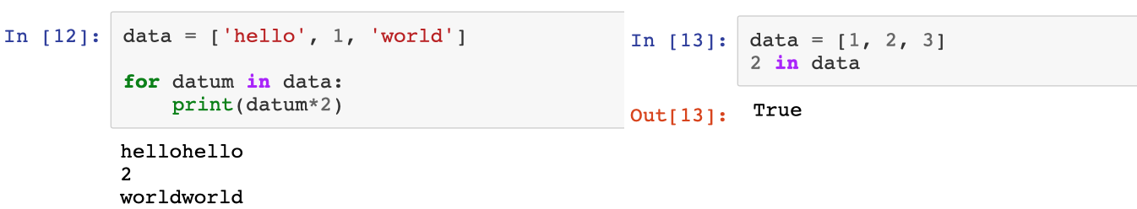

### **Tuples**

They store heterogenous data, where the order is relevant and it is contained in round brackets ( ). A common use is to pack together multiple return values from a function. (Sometimes you will see them referred as immutable lists. This is an unproper use.)

They are typically used to return several values at the same time from a function.

Their greatest limitation is the limited expressivity: each position has a meaning, but there is nothing directly expressing that meaning. To correct this, newer versions of python introduced **namedtuples**, where the meanings are explicitly referenced by names.

Even more information can be packed in using the **NamedTuple** factory from the typing module, from python 3.6 onward (it is a class definition). This allows to include a class description and information about the fields expected type (but do not enforce them).

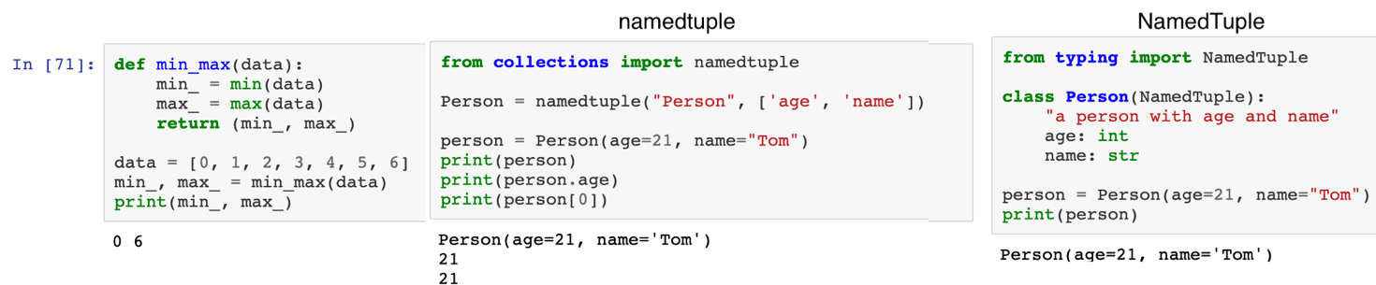

tuple

### **Dictionaries (maps)**

Dictionaries encode relationships between two different groups of values. They could also be seen as a list indexed by names instead of by position. These groups are usually referred as keys and values.

**values** can be any arbitrary python objects.

**keys** must be hashable objects, such as strings, numbers, booleans, tuples (if all the elements as hashable)

* The generic syntax is dictionary_name = {value1:key1, value2:key2}

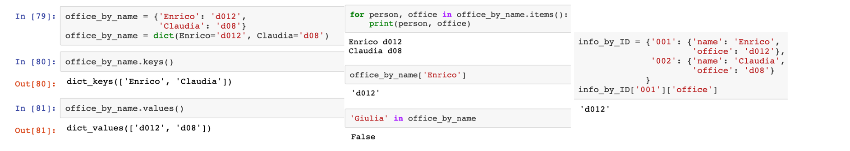

Lists search for inclusion of values (i.e. if the value 1, 2, 3… is stored inside the list), while dictionaries do not really care about the value, but rather check the keys, the name, that I am storing things in.

### **Objects**

They store data and provide a layer to interact with these data (we’ll see them later).

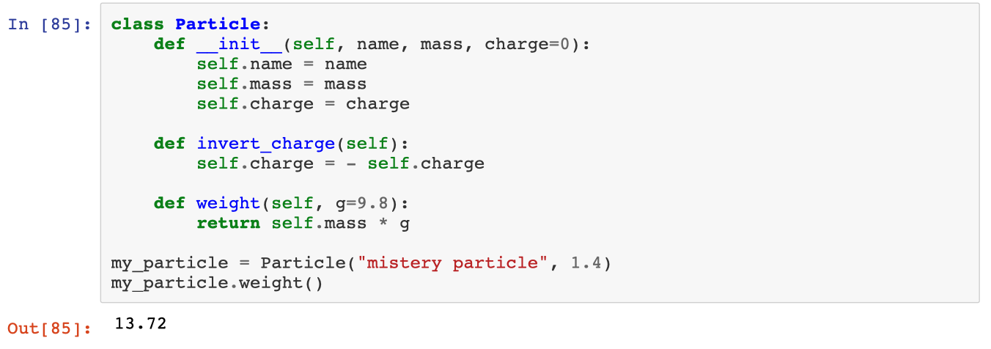

## **IPython shell**

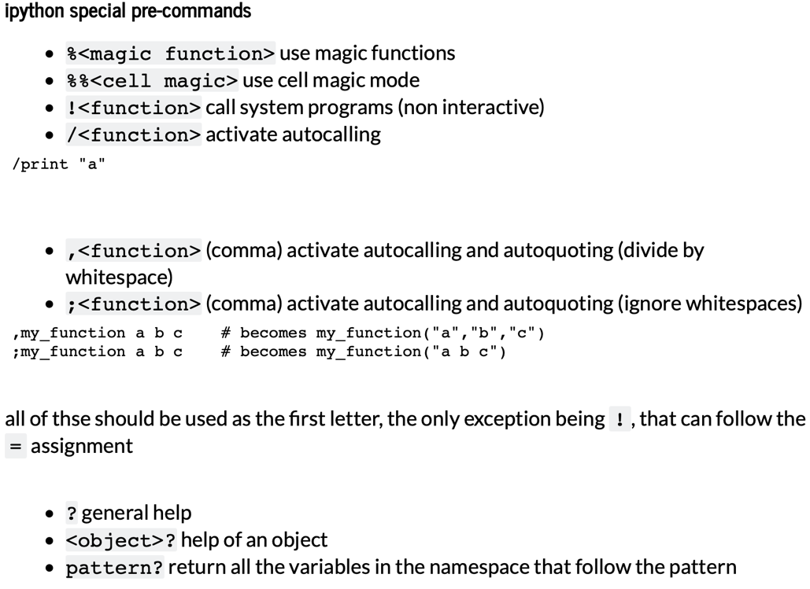More powerful shell compared to basic Python

cell= block of commands

cell magic= magic applied to a whole cell

How to execute a block of code:

* Shift+return = execute and go to the next one
* Control+return = execute and then stay there

Ex: %timeit -> tells me the time of execution

Ex: %%timeit -> tells me the execution time of the whole cell

Ex: !ls -> takes command shell commands

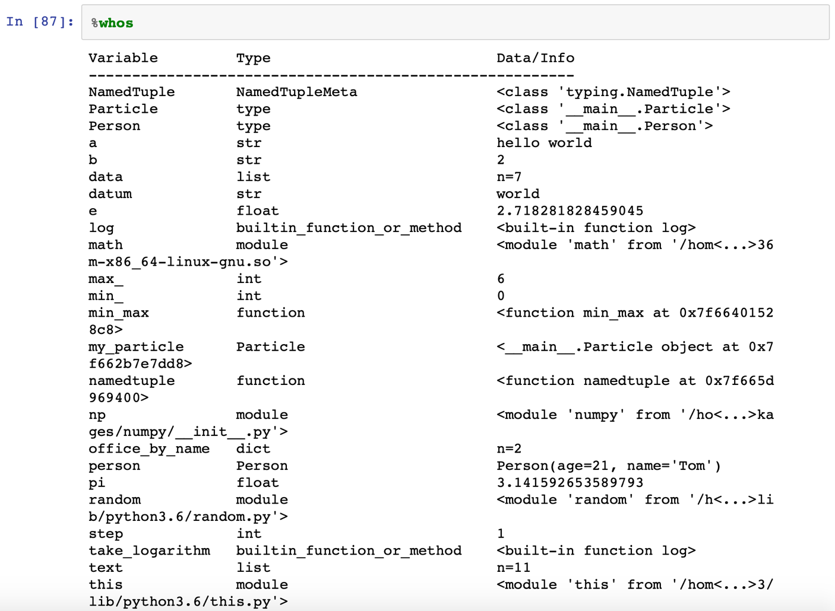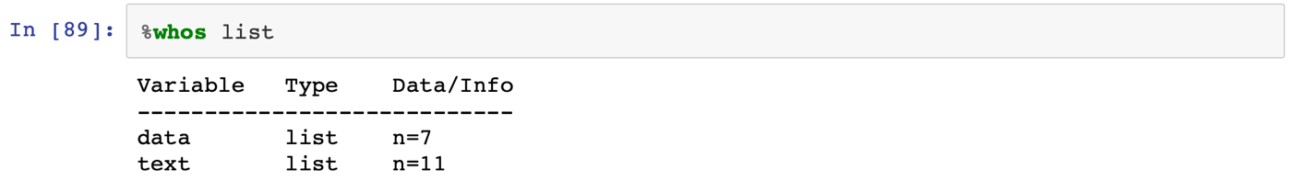

# **03_VERSION CONTROL**

Almost anything I’ll do will be paired with some form of coding, so I need to make sure that I consider

## **Correctness, replicability (and reproducibility), auditing**

* CORRECTNESS: to be sure that your code does exactly what you think it does; that any modification you perform does not introduce errors, and that if they do, you would be able to identify them and rollback from them
* REPLICABILITY - 1: you want to be able to repeat an analysis and obtain the same results, even after several months. This means keeping track of what are the prerequisites of the analysis, how to use it, on which data and which parameters.
* REPLICABILITY - 2: Allow to someone else to do the same, ideally without you having to be physically present in the same room with them to explain step-by-step all the processes
* REPRODUCIBILITY: allow others to reuse the same analysis (and in general your ideas) on other data and use cases compared to the one you worked on.
* AUDITING: keep the history of your project, knowing what has been done, when and why. This is necessary both to maintain the knowledge you have gained through the project and to allow some external reviewer to verify what you did.

What is necessary to have "healthy" code? (except from the basic things like, it runs, can be run by others, gives a consistent result, ecc ecc)

- version control

- documentation (comments or annotations for future me or someone else about what the code is supposed to do)

- test procedures (test correctness)

- procedure automation (ask minimum human interaction)

- well designed analysis pipeline

The main concept is the correct management of metadata (data about data)

Consider a function in your code: variable names are absolutely arbitrary, and you can replace them with anything else without changing the behavior of the function. But if the names are confusing, the code will be hard to understand, hard to modify and you would shortly forget what it is supposed to be doing. And there is so much more, alongside naming conventions and comments that one can keeps track of, if one is aware of it.

## **Distributed Version control and Code Source Management**

Version Control Systems are programs that allow us to:

-keep track of everything that happens

-roll back to a previous version at any moment

-visualize the difference between two versions of it

-keep track of "parallel world versions" of our work

and so on.

These work in tandem with Source Code Management tools, that also allow to keep track of:

Bugs, documentation, feature requests, etc...

You can use version control for any text-based file that you want, not just code. One can still use version control for non text-based files, but it loses a great deal of its power.

## **The idea behind git**

**version 1:** *everytime you modify a file, save it as a new version with the date of edit attached to it*

It is basically what you are already doing when you save many copies of the file but using date instead of numbers is more explicit. But if you have to coordinate various files it's still a mess.

**version 2**: *save a snapshot of the whole directory everytime you modify something, with the date in the name*

Good for keeping various file together, but a huge waste of file.

**version 3:** *go back to version 1, but keep a document (the manifest) with written what is the current state of the directory*

How would I know the state in previous moments in time? I would need a manifest for every state I went through

**version 4:** *keep several manifests, each one referencing the one before it and what changed between them*

How do you manage collaboration and such?

**version 5** *Identify each file and manifest with a unique hash (= if I don’t change the content, the name does not change; if I change the content, the name changes completely), store the various versions of the various files in a hidden subdirectory together with the manifests, build the directory based on those, exchange the blobs (files) and manifests with other people*

Now you have basically a simple implementation of git

ideas behind git:

-you have to choose which files to follow, and which files to ignore

-every time you change one or more files, you have to *commit* them to the VC, to let it know to create a new snapshot

-once in a while, you have to sync with the remote server (GitHub)

## **Using Git**

**git** is based on subcommands. This means that all the operations you need to do are going to be called as:

git <some_command> command options

Setting up git

First tell git who you are. This info is required, and will be attached to all the commits you do

git config --global user.name "Enrico Giampieri"

git config --global user.email [enrico.giampieri@unibo.it](mailto:enrico.giampieri@unibo.it)

Creating the repository

I need to create an empty folder to host my project

mkdir myproject

cd myproject

and now I can initialize the git repository (which is called myproject)

git init

Obtain the current situation of the repository

tells you which files are new, which are modified, and which have been deleted

git status

Adding a file to the one you follow

git add myfile.txt

git status

Commit the snapshot to the history of the repository

commit all the changes git commit -a -m "comment that tells what I did"

(-a = all -m = message) Commit tells git to take a snapshot of my file

you can also add one or more modified files again to tell git that you want to keep track of only those changes, and then do

git commit -m "my commit only of the staged modifications"

show the history of the current branch

for each commit it shows the message and the SHA (hash) of the commit git log

all the commits that are related to a specific file git log myfile.txt

show the edits

after you edit your file, you can check what has been changed for each file

git diff myfile.txt

or for the whole directory git diff

edit on the history

differences between the file and the last commit (**HEAD=**latest version before the last edit)

git diff HEAD myfile.txt

differences between the file and the commit before the HEAD (or the one even before that)

git diff HEAD~1 myfile.txt

git diff HEAD~2 myfile.txt

difference with a specific commit from the history

git diff <commit SHA1> myfile.txt

where <commit SHA1> is the sequence of number and letters that identifies a specific commit I can have them all printed out using git log (I can just use the first 6 characters of that sequence which are kind of the short version of the name associated to the commit)

revert back history

replace the current version of the file with a previous one from an older commit

git checkout <commit SHA1> myfile.txt

You could revert the whole repository if you forget the myfile.txt, so please the careful!!

if you want to go back to the latest commit you did, you can write:

git checkout master

beware that in both cases you will lose all the edits you have done and not commited!

removing and renaming a file

git rm <oldfile>

git mv <oldfile> <newfile>

watch out because git will do the modification and keep track of it.

You can always revert the changes by doing git checkout HEAD <oldfile>

git will explain precisely what to do to revert your changes, just remember to always check the status of the repo before committing!!!

sync with the main server - setting up the remote

The big advantage of distributed version control systems such as git is that you can store your repository on a remote server that multiple people can collaborate on.

First thing you have to set the remote server location (such as github), with one of two version depending if it is a public location or behind a ssh login.

git remote add <origin> ssh://login@IP/path/to/repository

git remote add <origin> http://IP/path/to/repository

you can have multiple remotes, and each one will have to be synced independently. origin is the most common name.

You can also duplicate an existing repository in a clean folder with

git clone http://IP/path/to/repository

this will automatically also set up the remote for you

To see the list of current remotes, you can use: git remote -v

note - updating the origin

If you want to change the location for a remote, such as origin, of your repository, you have to update it, don't try to use again remote add

git remote set-url origin <link to repo>

sync with the main server - push and pull

once you have the remote set up, every time you want to modify the project, you should

git pull origin master to get the latest updates from the other authors (i.e. any modification that has been done to the online repository).

After you do your commits, you can

git push origin master to share it with them (i.e. to upload to the online repository

the modifications you did locally).

**origin** is the name of the remote to which you are syncing, if you use a different name, work accordingly. **master** is the name of the main branch of commits (the possible parallel realities you can work on). If you work on different branches, change them accordingly.

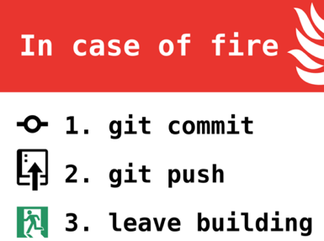sync with the main server - merging conflicts

If you and another author modify the same file, git will try to be smart and merge by itself the edits, as long as they involve different part of the file. If you are editing the same positions, it will complain, **stop you from committing** and ask you to **solve it by hand**, giving you a modified version of the file that highlights the stuff that you need to merge by hand. To limit this, try to keep each commit nice and well-focused, so that you don't risk modifying random stuff in a file and risk a merge conflict.

Ignoring stuff

sometimes you will have some files you don't want to be notified about, for example chaches, temporary files, etc... For these files, you can silence all the notifications by creating a .gitignore file, that is a list of filters that will be used to not show the files. For example, a .gitignore file could be: *.temp *.cache

you have to keep the .gitignore under version control like any other file!

Alternative histories - branching

Branching is the process by which you can create alternative realities in your repository to experiment without messing up other people's work. It can lead to some real mess, so use them sparingly.

### **Io che provo a capire cose**

(base) Air-di-Elisa:Desktop elisa$ mkdir project

(base) Air-di-Elisa:Desktop elisa$ cd project/

(base) Air-di-Elisa:projects elisa$ git init

Initialized empty Git repository in /Users/elisa/Desktop/project/.git/

(base) Air-di-Elisa:projects elisa$ git status

On branch master

No commits yet

nothing to commit (create/copy files and use "git add" to track)

(base) Air-di-Elisa:projects elisa$ git add myfile.txt

fatal: pathspec 'myfile.txt' did not match any files

(base) Air-di-Elisa:projects elisa$ git add myfile.txt

(base) Air-di-Elisa:projects elisa$ git status

On branch master

No commits yet

Changes to be committed:

(use "git rm --cached <file>..." to unstage)

new file: myfile.txt

(base) Air-di-Elisa:projects elisa$ git commit -a -m "created the file myfile.txt"

[master (root-commit) 3374464] created the file myfile.txt

1 file changed, 8 insertions(+)

create mode 100644 myfile.txt

*****

master = sono nel branch master;

root-commit = è il primo commit che faccio

3374464 = uniquely determines the version of the folder in question. In the future, whenever I want to reference to this state, this is the name that I can use.

created the file myfile.txt = the message that I added when I did my commit

1 file changed, 1 insertion(+) = I changed one file and I added 1 line

*****

(base) Air-di-Elisa:projects elisa$ git status

On branch master

nothing to commit, working tree clean

(ho modificato il file)

(base) Air-di-Elisa:projects elisa$ git status

On branch master

Changes not staged for commit:

(use "git add <file>..." to update what will be committed)

(use "git restore <file>..." to discard changes in working directory)

modified: myfile.txt

no changes added to commit (use "git add" and/or "git commit -a")

(base) Air-di-Elisa:projects elisa$ git commit -a -m "I added something"

[master dd854d4] I added something

1 file changed, 2 insertions(+), 1 deletion(-)

(base) Air-di-Elisa:projects elisa$ git log

commit dd854d4abfda8d30b87f26e9f1fb951a58e5966b (**HEAD -> master**)

Author: Elisa Sanzani <elisa.sanzani@studio.unibo.it>

Date: Thu Apr 2 12:53:09 2020 +0200

I added something

commit 54621958b815d4e5edabf5e8bad99d5de1e5d78a

Author: Elisa Sanzani <elisa.sanzani@studio.unibo.it>

Date: Thu Apr 2 12:31:34 2020 +0200

created the file myfile.txt

*****

git log keeps track of all the commits I did and prints them from newest to oldest.

(**HEAD -> master**) = this tells me that this is the HEAD commit, so this is the latest version of my repository and master is the branch that it is referring to

*****

(I modified the file and wrote “third edit”)

(base) Air-di-Elisa:projects elisa$ git diff HEAD myfile.txt

**diff --git a/myfile.txt b/myfile.txt**

**index c07dc16..1fcb674 100644**

**--- a/myfile.txt**

**+++ b/myfile.txt**

@@ -1,2 +1,3 @@

this is my file

-I added some text

\ No newline at end of file

+I added some text

+third edit

\ No newline at end of file

(base) Air-di-Elisa:projects elisa$ git checkout 546219 myfile.txt

Updated 1 path from 8d9463f (I went back to the first version. I can go back to the previous version just by doing the same thing using the commit name of the version I want)

*****

Now I will work on setting up the remote to my GitHub in the repository called projects, using a remote called origin

*****

(base) Air-di-Elisa:projects elisa$ git remote add origin https://github.com/elisasanzani/projects.git

(base) Air-di-Elisa:projects elisa$ git remote -v (tells me the full list of remotes)

origin https://github.com/elisasanzani/hello-world.git (fetch)

origin https://github.com/elisasanzani/hello-world.git (push)

(base) Air-di-Elisa:projects elisa$ git push origin master

Enumerating objects: 4, done.

Counting objects: 100% (4/4), done.

Delta compression using up to 4 threads

Compressing objects: 100% (2/2), done.

Writing objects: 100% (3/3), 324 bytes | 324.00 KiB/s, done.

Total 3 (delta 0), reused 0 (delta 0)

To https://github.com/elisasanzani/projects.git

cdc591e..6344cc9 master -> master

# **04_TESTING**

Correct code is a code without bugs or errors

*bug*: there is a bug in the code when this code behaves differently from what it's written in its documentation

In the documentation we include the external documentation (the manual) the internal one (docstrings) and the implicit one (name of the function and of its arguments).

Can be considered bugs also comments and variable names that do not align with what the code is doing, even if less so.

To correct a bug I do a bug regression test, given that any modification that I do to my function still makes it work correctly, so that my function still passes all my tests.

*error:* a code has an error when behaves differently from what it was written to do (logic and behavior differ).

For example, a sorting algorithm that does not sort, or that in some corner cases sorts incorrectly.

For any object that I can define in Python, if I put a string, the ***docstring***, right after the definition (for example in a function def funcname(arguments):function), it will appear as the description of my object when I do help(name_of_my_obj). Always write the docstring for every function I write.

What is really important when I write a function is a concise description of my function that tells me what it is supposed to do, what parameters it accepts and what kind of result it returns; any other note is nice, but not as essential as that. Also a slightly more extended explanation is important, as well as examples.

An example on how to write good documentation is from the numpy package (do import numpy and then help).

## **Purity of functions**

A function is called pure if:

* with the same input, it returns the same output (it is deterministic)
* it does not change the state of the rest of the program.

This lets you:

* know that once you've proven that the function is correct, it will always be correct
* if you change the implementation, as long as the input-output relationship is the same, the functions that depend on it are going to be fine

Pure functions are very useful, in particular because they are the easier to test and prove correct

Example: sum among numbers is pure.

Using global variables (or non-local ones) inside a function stops it from being pure.

## **Types of test**

we want to test if a function is correct, what kind of test can be done?

advancement test: edits to the function introduce the new features I desire

regressions test: edits to the function do not lose functionality that other code relies on

positive tests: the code does the things I expect it to do when I give the right parameters

negative tests: the code fail the way I expect it to when I give the wrong parameters

## **Strategies of testing**

to test the correctness of a single function

### **Informal testing**

When we write a function, we usually test if it is working as we expect. This is a form of testing, and is necessary, but is far from enough.

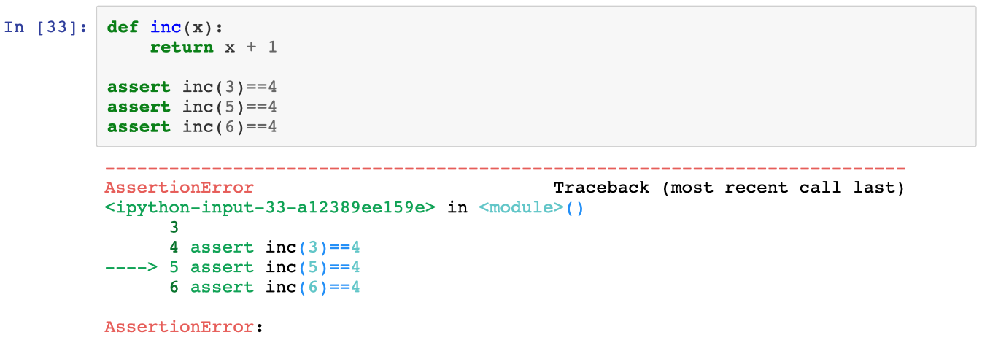

**assert**: key word that I can use to test if a statement is true. In this way in the program I can test if that value of something corresponds to what I am expecting.

Syntax: assert function(var)==certain_number

Assert should always be used for testing, never use it for input validation because first I am not gaining anything, but a list of unintelligible errors. Then it is not specific; there are many reasons why a value may be invalid and if I use assert it can just give me an assertion error. Lastly, assertions are not guaranteed to be executed; there are certain situations where Python may decide to skip all assertions.

NO YES

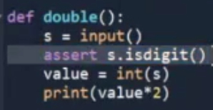 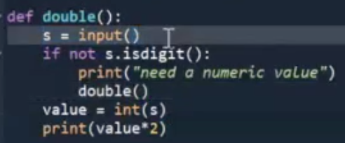

### **Unit testing (anecdotal testing)**

What you tested with just bare asserts, you save as a separate script. Any time you modify the code, run the tests to check that everything is still working according to plan.

Do not commit code that does not pass all the tests!

If you find a new bug:

1. write a test that reproduces that bug (i.e. that fails for that case)
2. adjust the function until the test passes
3. keep the test there forever to avoid regressions in the future

As a general rule, I need at least one example of a typical case use, plus one for any limit case.

For every change I make I have to be sure that my program still works, so it is useful to do a series of test to check my program after any modification.

A good library to start with unit testing is **pytest**. Pytest is a command line program (so use it from shell) that:

* searches all the current directory for *.py files
* in each one of those, searches all the functions named test_<something>
* executes all of them and keep track of the results
* prints a summary of the tests

One could execute the test code by hand, but there would be several disadvantages

* one would have to execute each function one by one (instead of having them discovered by pytest)
* at the first error, the whole execution would stop, giving me a partial view of the situations; pytest visualizes all the errors
* the bare assert results are not very informative; pytest results are more explicit

To run pytest: !pytest nomeprog.py

Pytest can also check if we expect the function to raise an exception under certain circumstances, which would be quite difficult to do with normal code. Pytest automatizes our testing procedure, but we still have to think and write a great number of tests, and most of them are going to be similar with small variations. The best solution would be for the computer to generate and keep track of tests for us. This is not possible in a literal sense, but we can get pretty close to it.

*Example:* test on a sorting algorithm that I wrote.

You would need to test at least: that an out of order list, such as [1, 3, 2], gets sorted [1, 2, 3]; an empty list gives back an empty list; an already sorted list [1, 2, 3] gives back the same list as output.

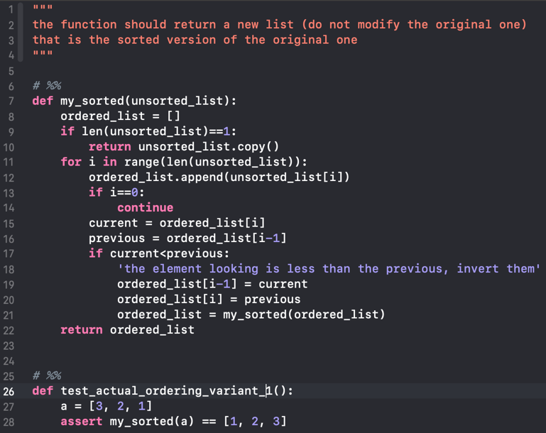 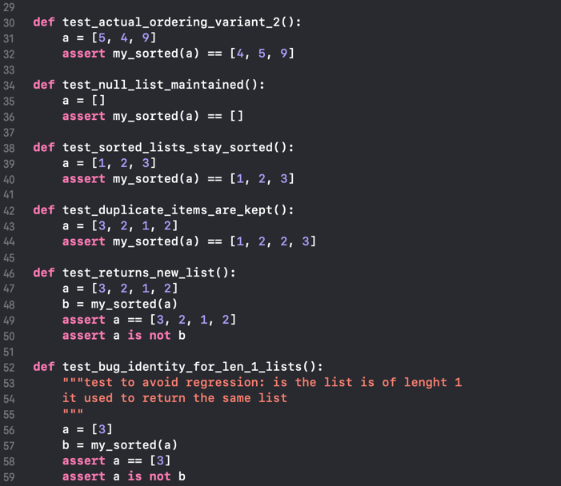

### **Property testing**

I can generalize the anecdotal tests I wrote earlier, trying to check not for individual results, but general properties and symmetries of my code.

In **unit testing** for each test and in each individual case

* + 1. I have to specify the input
    2. I have to specify the expected output (or error)

In **property based testing**:

* I need to specify the kind of output I will provide to the function
* for each test specify the invariants of that test property

Property testing is based on creating tests that focus on the *properties* of the function – the “requirements”. These properties should be things that are true for *any* correct implementation.

The library I am going to use will specify the input data in a random way according to the rules I specified. It will throw them at the function actively trying to break it and if it finds an example that breaks the expected properties of the functions, tries to find the simplest example that still breaks it.

It keeps track of that example and will provide it to all the future iterations of the test. Property based testing does not replace unit testing; it extends it and makes it more powerful and reduces the amount of trivial and repeated code we have to write.

Of course, to use it one needs to think harder about what they want to test, but you wouldn't be here if you were afraid of thinking.

The library we are going to use is called **hypothesis**. Hypothesis leverages libraries such as pytest for the basic testing, but generates test automatically using **strategies**. A **strategy** defines how the data are randomly generated and passed to the function to be tested.

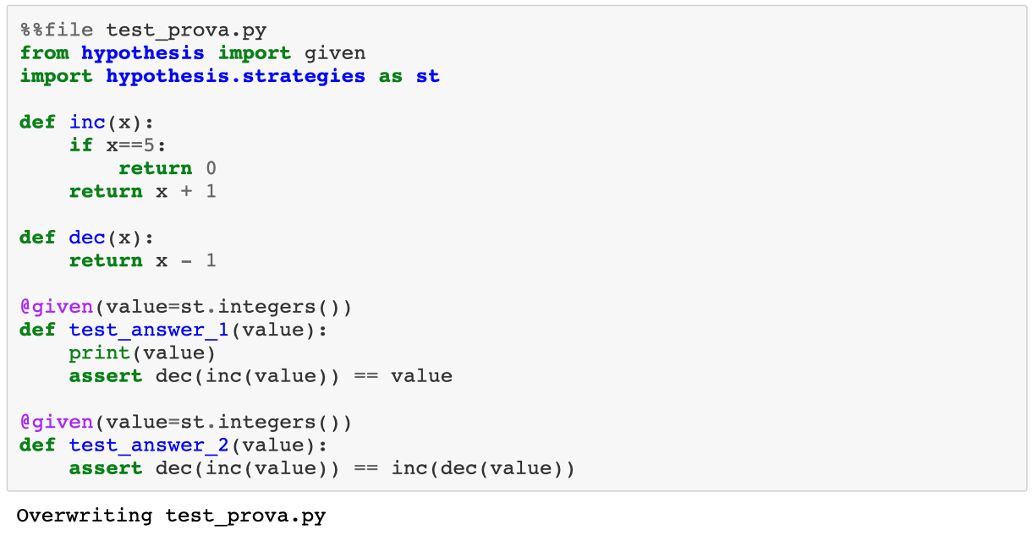

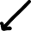

Here I am telling hypothesis to just toss every kind of number until it finds something that breaks my function.

(in output it tells me that there is a problem with the number 5)

To write property based testing one doesn't need to start from scratch, but can progressively extend the classic unit tests. For a starter, replace the fixed parameters with the **just** strategy.

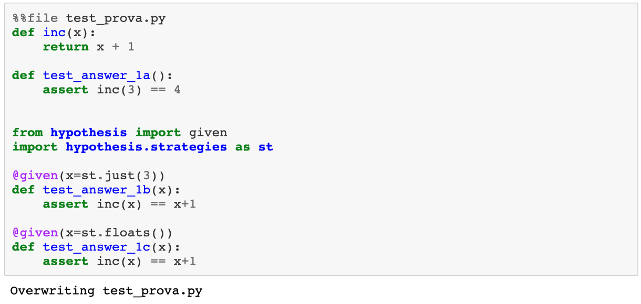

If we want to ignore some of these cases, we could use the **assume** function, that restricts the random function generation for the testing of each individual function.

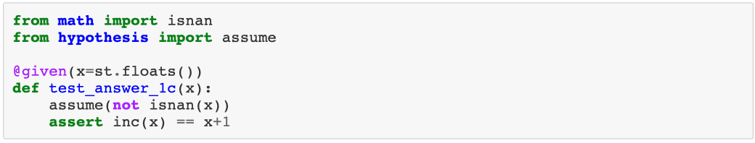

## **(Some) Patterns of properties to be tested**

When times come to start creating your own properties, what properties should I use?

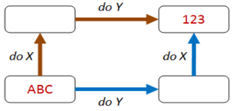

* *Commutative property*: these kinds of properties are based on combining operations in different orders, but getting the same result (classic example is commutative property)
* *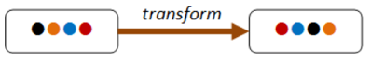Conservation law*: these kinds of properties are based on an invariant that is preserved after some transformation (in the diagram the transform changes the order of the items, but the same four items are still present afterwards).
* *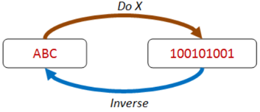Existence of an inverse function*: These kinds of properties are based on combining an operation with its inverse, ending up with the same value you started with (in the diagram doing X serializes ABC to some kind of binary format, and the inverse of X is some sort of deserialization that returns the same ABC value again).
* *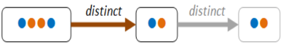Idempotence*: These kinds of properties are based on “idempotence” – that is, doing an operation twice is the same as doing it once (in the diagram using distinct to filter the set returns two items, but doing distinct twice returns the same set again).
* *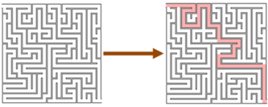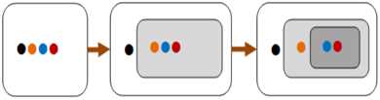Induction*: These kinds of properties are based on “structural induction” – that is, if a large thing can be broken into smaller parts, and some property is true for these smaller parts, then you can often prove that the property is true for a large thing as well. Induction properties are often naturally applicable to recursive structures such as lists and trees (in the diagram we can see that the four-item list can be partitioned into an item plus a three-item list, which in turn can be partitioned into an item plus a two-item list. If we can prove the property holds for two-item list, then we can infer that it holds for the three-item list, and for the four-item list as well).
* *Hard to prove, easy to verify*: Often an algorithm to find a result can be complicated, but verifying the answer is easy (in the diagram we can see that finding a route through a maze is hard but checking that it works is trivial).
* 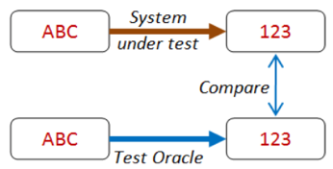*Oracle testing*: In many situations you often have an alternate version of an algorithm or process (a “test oracle”) that you can use to check your results. For example, you might have a high-performance algorithm with optimization tweaks that you want to test. In this case, you might compare it with a brute force algorithm that is much slower but is also much easier to write correctly.

## **Test driven development**

In the test driven development, code and tests are written together, starting from the specifics.

There are several variants of this concept, but the main idea is that you shouldn't wait to finish your code to write your tests. Write them alongside, even before the code itself, so that you can be sure that the function follows what you expect it to do. When designing complicated architectures, where the design is necessarily top-down, this is a precious approach.

In the top-down approach, we will develop our code as if everything works perfectly, and then we will implement it for real:

1. we start from the "final" function, calling the others as if they exist
2. implement a "stub" function of each one, that does nothing aside of allowing us to execute our code
3. write tests that represents the properties that we expect from our real function
4. replace the stubs with functions that actually have these properties

## **Cellular Automaton: rule 30**

A cellular automaton consists of a regular grid of cells, each in one of a finite number of states, such as on and off. The grid can be in any finite number of dimensions. For each cell, a set of cells called its neighborhood is defined relative to the specified cell. An initial state (time t = 0) is selected by assigning a state for each cell. A new generation is created (advancing t by 1), according to some fixed rule (generally, a mathematical function) that determines the new state of each cell in terms of the current state of the cell and the states of the cells in its neighborhood.

An elementary cellular automaton is a one-dimensional cellular automaton where there are two possible states (labeled 0 and 1) and the rule to determine the state of a cell in the next generation depends only on the current state of the cell and its two immediate neighbors.

Rule 30 is an elementary cellular automaton introduced by Stephen Wolfram displaying aperiodic, chaotic behavior. 30 is the smallest Wolfram code which describes its rule set (00011110).

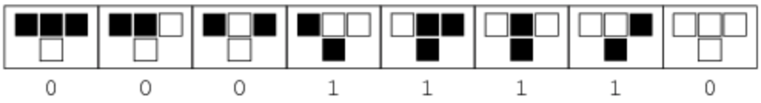

# **05_LOGGING AND DEBUGGING**

This lesson will deal on how to make sure that our code is doing what is supposed to be doing. This is related to testing but can be viewed as complementary to it.

We will discuss: debugging, assertions, logging; and given time: linters, type checkers, warnings

All these tools help us ensure that the program is doing what is supposed to be doing.

While tests check that the program logic is correct, these tools helps you check that the program is implementing the operations you think it's doing. Most of these techniques are necessary to help you understand what you program is actually doing, instead of what you think it is supposed to be doing.

## **Debugging**

A debugger is a program that attaches itself to yours, monitors its state and allows you to control the execution in real time.

What we do when we execute our programs one line at the time from an editor like spyder is basically a manual for of a debugger. Python and IPython come with a basic debugger for the command line, but most programs provide you with more advanced (and easy to use ones). (pdb=python debugger)

The basic operations can be divided in two main categories:

-managing the execution

-examine and modify the program state

1- For example, in the command line do: %**run** -d mioprogramma.py dopo aver aperto ipython

And then I can use these commands to move through the debugger:

* **l**(list) Lists the code at the current position
* **w**(here) What is the exact position in the call stack
* **n**(ext) Execute the next line (does not go down in new functions)
* **s**(tep) Execute the next statement (goes down in new functions, steps into the function)
* **r**(eturn) Return out of a subroutine
* **bt** Print the call stack
* **p**(rint) print the result of the expression
* **a** Print the local variables
* !command Execute the given Python command (instead of pdb commands)
* **u**(p) Walk up the call stack
* **d**(own) Walk down the call stack
* **h**(elp) Show a list of commands, or find help on a specific command
* **q**(uit) Quit the debugger and the program
* **c**(ontinue) Quit the debugger, continue in the program
* <Return> Repeat the previous command

2- Or I can use a graphical debugger like <http://www.pythontutor.com>

3- Or I can do it with the debug tools provided by Spyder, which even allow me to execute one cell at the time (and it opens ipdb, i.e. IPython debugger).

What I can also try to do is modify my set of data that I have given, on the fly, i.e. directly from my command line (for example dati = [1, 2, 3, 4], in my command line I can write !dati[-1] = 3 and in this way I modify the last element of dati, which now is dati = [1, 2, 3, 3]). I was able to change the parameters to see that if I have a critical point, when I change something than what happens, allowing me to have control of what goes on.

If my program is hundreds of lines this may become a bit complex and I can insert some breakpoint, which means that my system will run until it reaches a breakpoint.

### *Breakpoints*

Sometimes we know where the error is likely to be and would like the program to proceed with the regular execution until some given point. These points are called breakpoints, and allow for a smoother debugging experience.

Since Python 3.7 there’s a built-in breakpoint() function that calls the configured debugger (like ipdb).

Just place breakpoint() anywhere in the code to get into the debugger shell.

Additionally, if you want to run a python script and ignore all breakpoint() calls in the code it’s possible

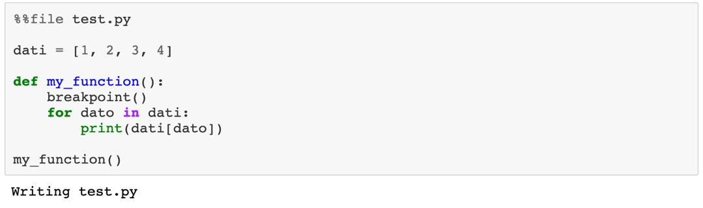

## **Assertions**

They are useful to express your expectations as the programmer, about the code.

Example, in code: **assert** 1==0, "I was not expecting that"

Don't rely on it, as they can be removed from the execution by using the flag -O (Optimize) when calling the python interpreter and also they are not very informative about the problem that occurred.

A common mistake is to use assertions to check the inputs of a function. This is an improper use of the assert, both due to the fact that it can't be relied and that they are not providing discriminative and informative errors to the user. They should be used for testing for sure, but in normal code they have only one real use: express invariant of your code (think back about property testing).

Assertions express in code that some characteristics of the code has to be valid, or something has gone wrong. For example:

**def** my_smart_sort(sequence):

*# some sorting code*

sorted_sequence = someting(partial_result)

*# the resulting sequence has the same lenght of the original one or someting is wrong*

**assert** len(sorted_sequence) == len(sequence)

**return** sorted_sequence

Assert does not change the execution of the code unless something has gone very wrong. Asserts should be removable by my code without changing anything about it.

You can look at asserts as a stronger form of comments: comments can potentially go out of sync with your code, while assert can't, so they can communicate to the programmer reading the function with a higher degree of confidence.

We could use a better (albeit slower) assertion library, grappa, to help get better syntax and better error results: **from** **grappa** **import** should, expect

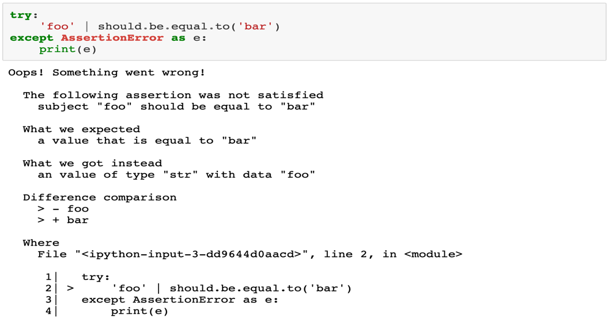

This expression is equivalent of saying assert foo == bar but in return I have something more verbose and that tells me what I was expecting and what I got instead.

It also allows me to express compound operations.

**with** should({'foo': 'bar'}):

should.be.a(dict)

should.have.length(1)

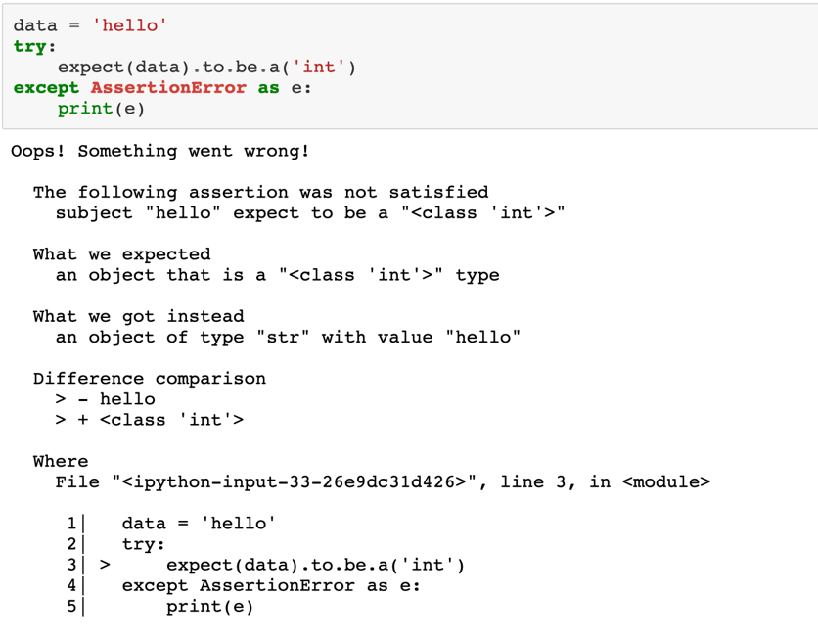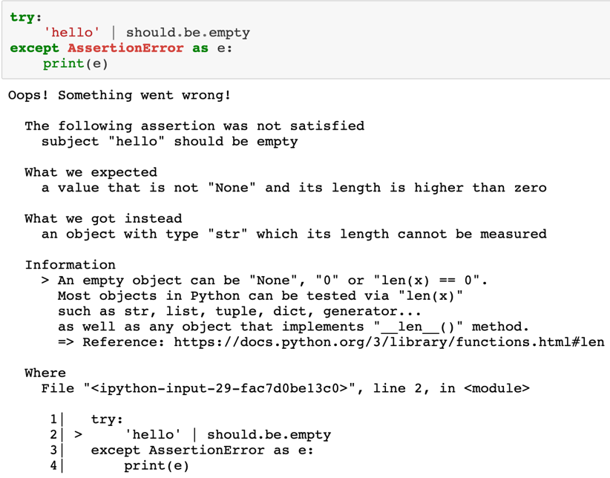 should.have.key('foo').that.should.be.equal.to('bar')

**Logging**

When you execute your code and print the internal state of the program to check that is working properly, that is a rudimentary form of logging. Printing the state of your program works fine as long as your program is simple, and the amount of state is small. For anything more complicated, you need to use a logging system.

The basic idea of a logging system is to standardize how and what gets written on a file.

example: print("ciao!") -> prints to std output

example: import sys

print("ciao!", filesys.stderr) -> prints to std error

I can also print my output in stdoutput and my error in a separate file.

Python does provide a standard library, logging, by default **import** **logging**

It provides a way of discriminating between the importance of the logging that I am doing, with 5 different levels of importance: debug, info, warning, error, critical.

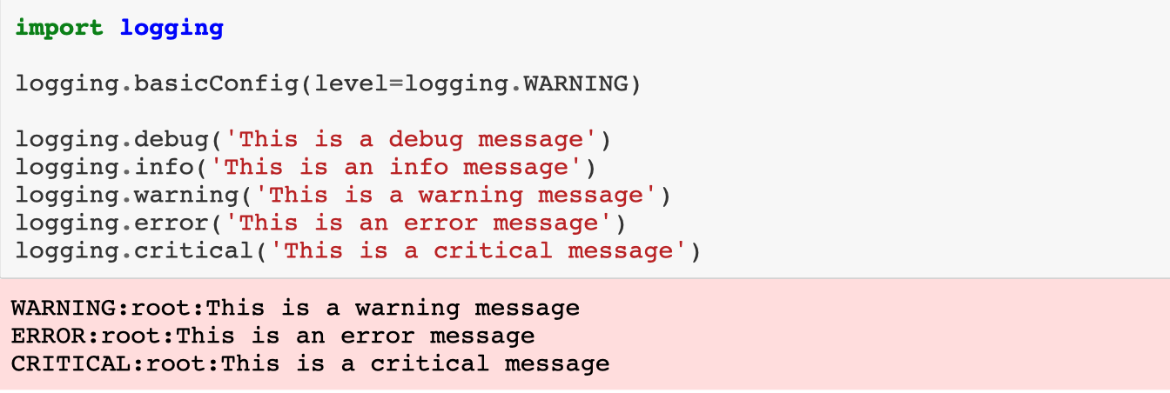What one does if there is a problem, is to fill the program with prints of error messages, which one then has to remove. A better way of doing this is just putting logging into the right position, so for example critical logging before bad errors, error logging before something that I do not like, warnings when there are conditions that sound that may cause troubles, and then just print everything together. Then I can select which kind of logging I wanto to see or not, so I do not need to hunt for them and selectively destroy them.

I say to print everything from warning up (i.e. warning, error and critical)

It is “kinda lacking some context”, so I’d better use structured logging.

A better library, for structured logging, is called eliot, that allows for a more structured logging instead of just printing to stder.

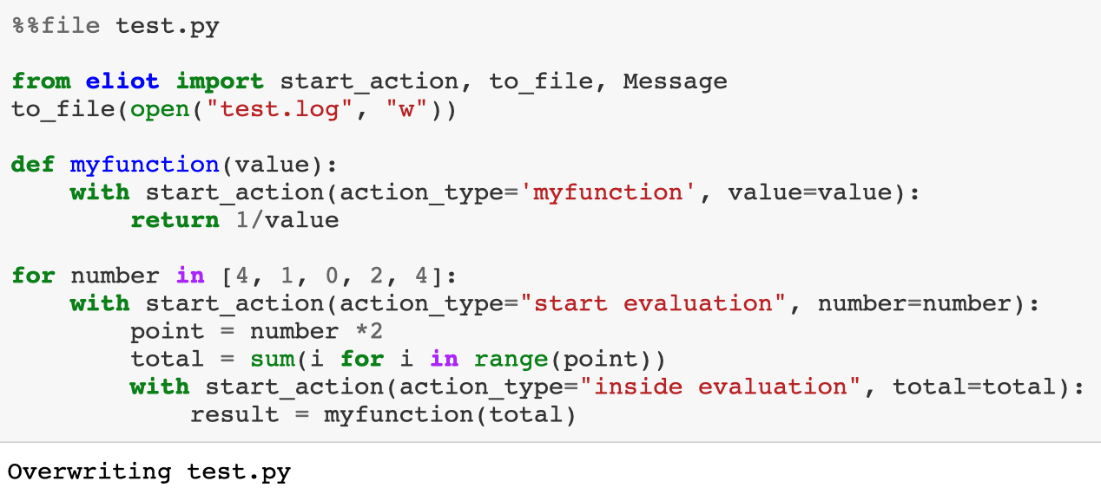Instead of printing I say that I am starting some kind of action. Everything that I am going to do is going to be put inside the .log file.

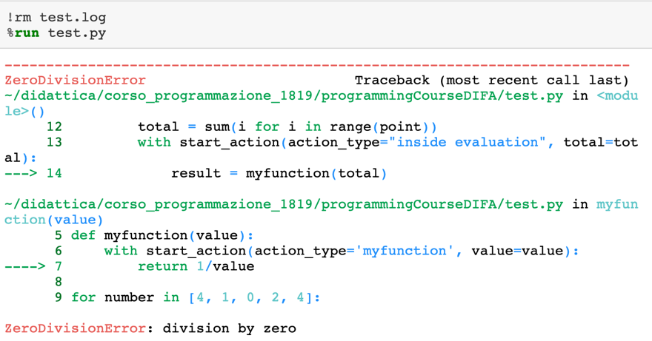

Suppose something went wrong and I want to know what happened.

With logging it is hard to understand why and when something went wrong, it does not give me a lot of context.

Libraries like eliot (and others) try to improve this, they try to give a structure to my log that can be used to obtain the context, automatically.

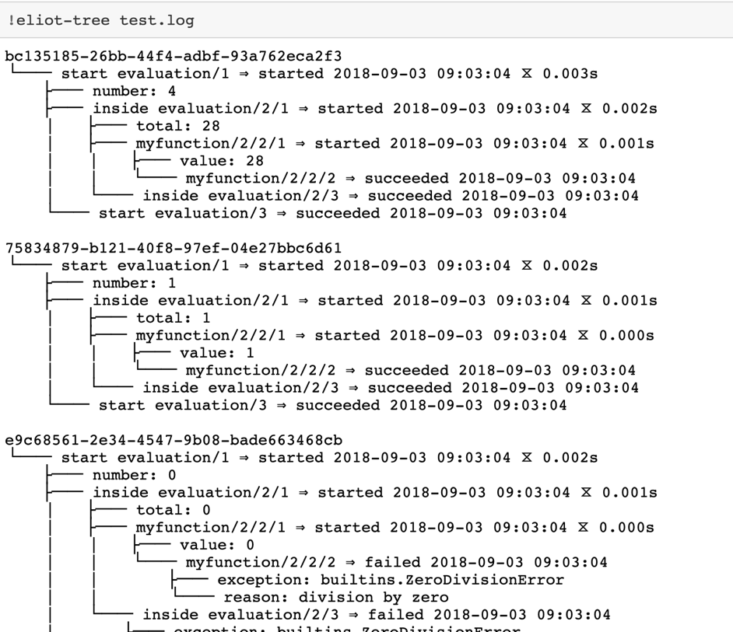

eliot-tree is a program which runs through the log file and provides me with a structure for it. So, when I meet a failure, I can trace back to what went wrong and why.

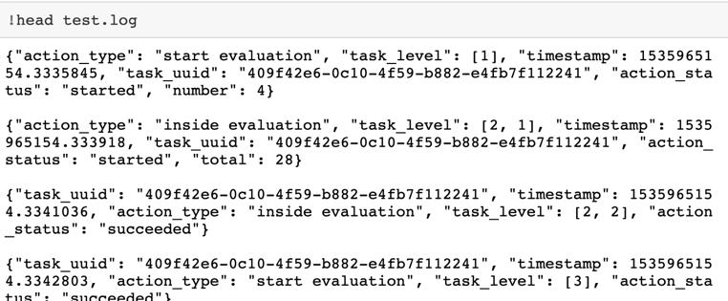

This is the log file, which basically is a sequence of time stamps and actions which succeded or failed

What if you want to see the results in real time?

A better solution is to periodically refresh the result of eliot-tree, piping the tail of the log file in it:

tail -f test.log | eliot-tree

for example, if we make our program be slower (simulating a slow computation)

The only limitations are:

* you have to interrupt the tail process manually
* actions are written only when completed, so if you have very high level actions this will not print until they are done

Otherwise, if you are used to live in the matrix, you can watch the log file directly with:

tail -f test.log

## **Warning systems**

Warnings are a way to communicate directly with the user and let them know that there is something fishy going on, half way between logging and execution. import warnings

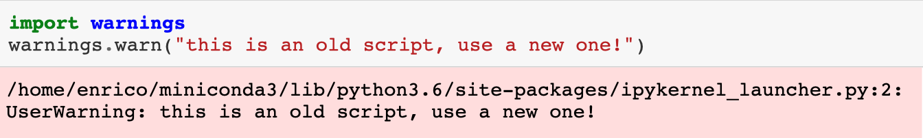While logging is something that is run consistently, warnings should appear only in some specific situations. A typical case is to inform your user that one of the functions that is being used is going to be removed from the next version of your library and that they should use something different. Warnings are something that my program is aware of.

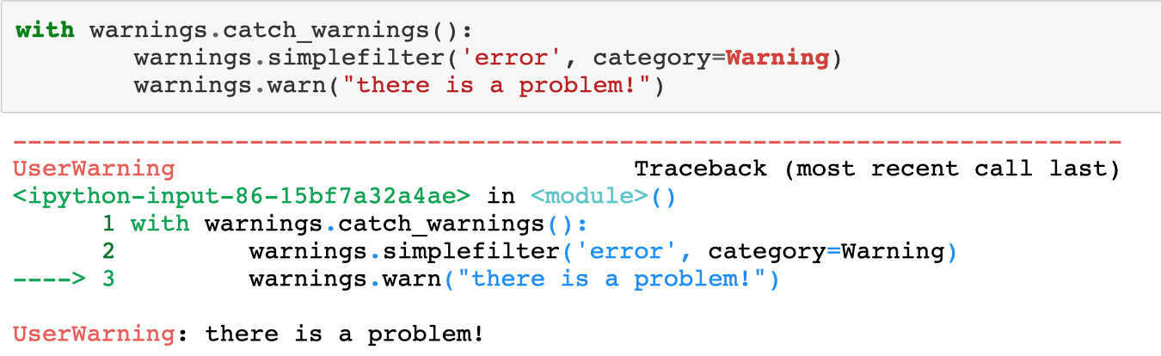If you want to raise an error when you catch a warning, you can use a specific context manager.

I want to do this if the library the I am calling gives me weird warnings due to maybe some version of the functions that will be shortly after updated

Or I may want to do the opposite you might want to silence certain warnings as you know what you're doing.

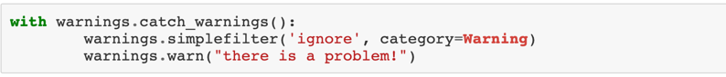You probably should not use this code! This makes sense only if the library that I am using raises a waning when it is working with another library.

## **Linters**

Linters are programs that check your code for possible mistakes and errors before the execution.

There are several of them, with various level of informations that they can gather.

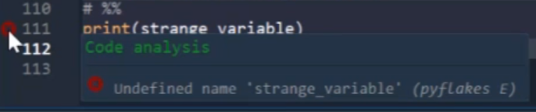Most editors can be configured to run them in the background and show the resulting information directly in the editor window.

They tell for example when I have defined variables that I actually never use, or when I am trying to use variables that I have never defined.

Examples of things that they will catch are: variable definited but not used; overloading of existing functions; syntax errors and so on.

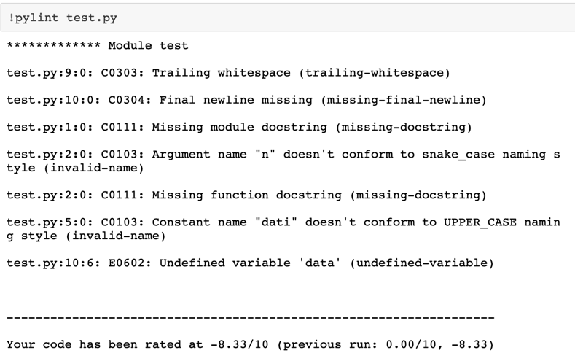They are extremely useful when working with a dynamic language such as python, as they provide some functionalities of the traditional compilers, otherwise especially in dynamic languages, in these cases I would get no sign of mistakes until the execution.

Some of these linters are:

I run pylint on this code

* pylint
* pycodestyle (previously called pep8)
* pyflakes
* flake8

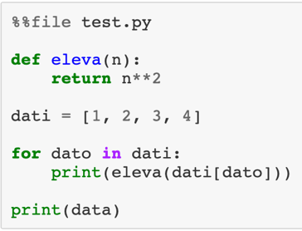

Obviously not all suggestions are equally relevant (blue less, red more), but they can spot several **code smells** before you run a long simulation

C0303, C0304 ecc. are all code names for the syntax warnings an so on, things for which my code will run, but it would be better if they were different. E0602 is instead a proper error. In the end it scores the code.

## **Static type checking**

A specific type of linter are the static type checkers, that are made possible by new syntax from python 3.

I can do “type hinting”, mainly for the user, of what type a certain function is supposed to work with; even if I still can give the function any type I want (help(my_func) tells me information about this).

Python is a dynamic language but is still strongly typed. One just doesn't have to declare the typed beforehand. What they introduced is the possibility to annotate the code to express expectations over the type of variables, arguments and functions. This does not have any effect on running the code but allows type checkers (the most famous one is mypy) to assess if the code is correct.

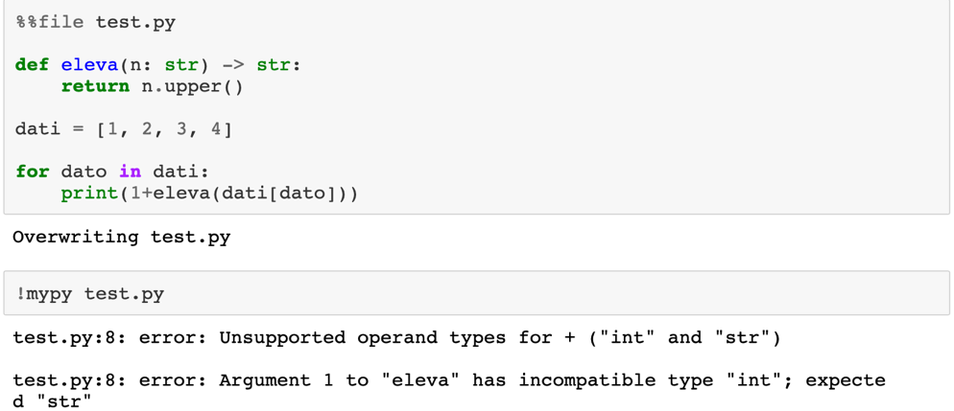For example, the following code has a lot of issues, but they might not be immediately apparent just looking at it.

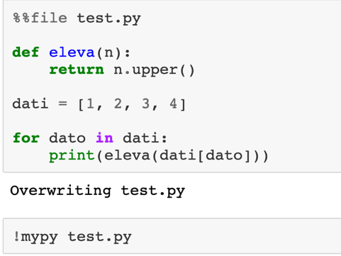

If we don't put any typing information, mypy doesn't complain and doesn't do anything.

I can start introducing types information and will find progressively more possible mistakes.

Types are specified with a colon (:) after the argument or variable, followed by the type object that it should have. For the return type, one can use an arrow ->

I can specify more complex types using the library typing, that allows to specify very complex structures (it is included in python).

This allows me to annotate only the code I care about without having to deal with typing everywhere.

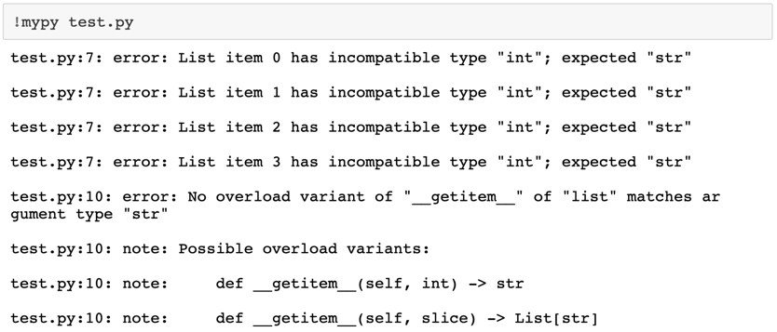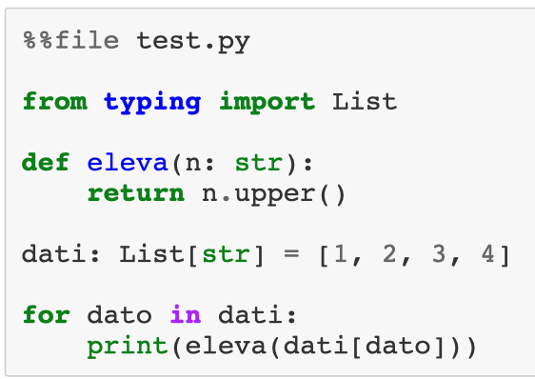

(dati should be a list made of strings but then I out numbers in it. Python will not say anything but mypy will complain)

You can find more info about the checking and how to use it on this blog posts:

* A general overview of the type systems

<https://www.bernat.tech/the-state-of-type-hints-in-python/>

* An in-depth discussion of how the type system works and how to use it
* [S01E01](https://blog.daftcode.pl/first-steps-with-python-type-system-30e4296722af)
* [S01E02](https://blog.daftcode.pl/next-steps-with-python-type-system-efc4df5251c9)
* [S02E01](https://blog.daftcode.pl/csi-python-type-system-episode-1-1c2ee1f8047c)
* [S02E02](https://blog.daftcode.pl/csi-python-type-system-episode-2-baf5168038c0)
* [S02E03](https://blog.daftcode.pl/covariance-contravariance-and-invariance-the-ultimate-python-guide-8fabc0c24278)

# **06_VECTORIZATION**

## **Precision (Floating point numbers)**

The representation of numbers inside of a computer is kind of a tricky business because basically we have to represent potentially infinite numbers in a finite space. This leads to approximation and some kind of errors.

When we discuss numerical computation, you will see the non-integer numbers are referred as *floating point numbers*:

-what are they

-how are they related with the numbers we manipulate normally?

Some rules to keep in mind

-As soon as you start working on a computer, you have to forget about the idea of continuous.

-Any number that a computer can manipulate, and output is, by necessity, with finite precision, and only an approximation of a real number (as in a member of the real group).

Numbers in a computer are represented with a finite number of bits (0 and 1 in binary).

Integers are simply the traditional integer numbers expressed in binary format and can range from 8 bits (one byte) to 64 bits, being them whole numbers there is not a problem (other than overflow, i.e. not enough bits).

How would you represent a number with a non-integer part?

1) One could use a fixed part of your available bites to represent the integer part and another one to represent the floating point part, but this would severely limit the range of numbers that can be described.

2) The other option is to use the scientific notation to represent them: this way you can get almost as big or small as needed!

In this case, to represent the number, we divide it in 3 components:

* a field called Significant S
* a field called exponent e
* a bit for the sign

so the number will be represented by the following: 𝑛 = (−1)𝑠⋅𝑆⋅2𝑒

Depending on my system I have 32 or 64 but usually 10 for exponent, 50 for significant and one for the sign (I sill have a limit)

Precision and round off

Due to the limited nature of the floating point numbers, we will have problems representing some numbers:

- Irrational numbers (√2, 𝜋)

-Several rational numbers

The first one might not be a surprise, but the second one is quite surprising: the information contained in them is finite! The problem with several rational numbers is that those numbers still require an **infinite number of digits** to be written down. (think of the fraction 2/3=0. $\overline{6}$. If one has to work with a finite number of digits, it would be represented as: 2/3=0.66666667. That is an approximation, and could lead to numerical imprecision, but it's the best we can do with finite space).

A common source of errors is that the "simple" fractions in base ten might not have a finite representation in base 2 (for example, 0.1 is represented as 0.0 $\overline{0011}$) so at one point I have to make a truncation.

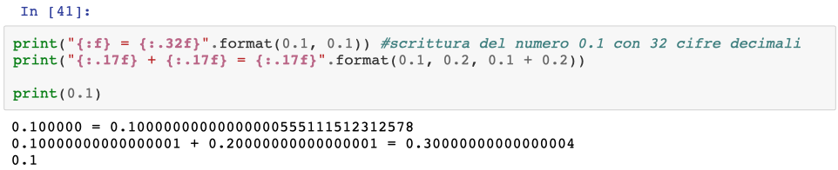

Therefore 0.1+0.1+0.1-0.3 returns 5.5…· 10-17 instead of 0 so in case I tested for 0 as a result, I’d get false.

Python works with 53 bits of precision, so the values that it is working with, internally, are not the same as the ones that it shows using a simple print.

Testing could be difficult because I could get a number basically 0, but not exactly 0.

[Python documentation on the floating points](https://python.readthedocs.io/fr/latest/tutorial/floatingpoint.html)

Floating point arithmetic

Due to their structure, floating point arithmetic is not equivalent to the one you are familiar with using the real numbers.

* associativity(+) : (𝑥+𝑦)+𝑧 ≠ 𝑥+(𝑦+𝑧)
* associativity(×) : (𝑥×𝑦)×𝑧 ≠ 𝑥×(𝑦×𝑧)
* distributivity : 𝑥×(𝑦+𝑧) ≠ (𝑥×𝑦)+(𝑥×𝑧)
* round : 𝑥+𝜖−𝑥 ≠ 𝜖
* division : 𝑎/𝑏 ≠ 𝑎×(1/𝑏)
* algorithms : (𝑎+𝑏)×(𝑎−𝑏) ≠ 𝑎2−𝑏2
* ecc.

Exact fractions, on the other end, are all the fractions that can be expressed as 1/2𝑁 (i.e. ½, ¼…)

[What Every Computer Scientist Should Know About Floating-Point Arithmetic](https://docs.oracle.com/cd/E19957-01/806-3568/ncg_goldberg.html)

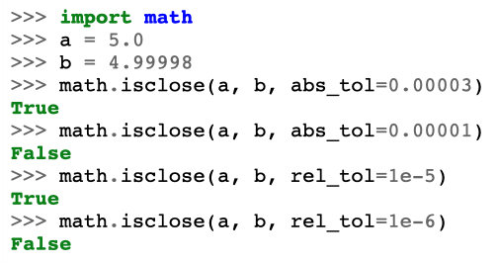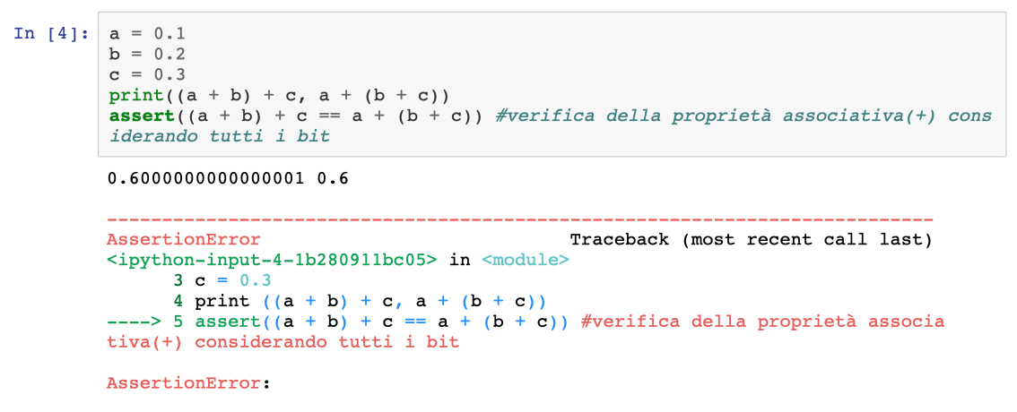

If you have to test if two floating point numbers are **close enough** to be for all intent and purposes considered equal, you can use the function math.isclose

(For every testing rely on this not on strict equality)

If you don't care about numerical performances, you can also use the built-in modules

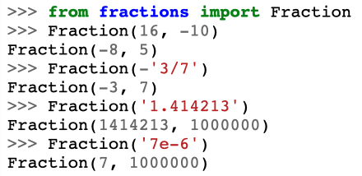Decimal and Fraction

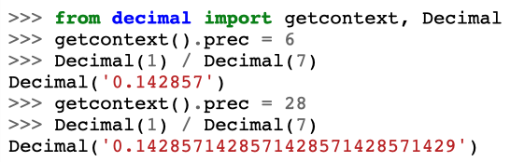

In decimal I can specify how many precision digits I want

Similar with fractions, where simplification of fractions does not give me real numbers but still fractions. This works as long as I do not have to do square roots or difficult operations. It is way slower but basically I have infinite precision.

Floating point exceptions

Alongside precision errors and round offs, there are several possible exceptions that can be raised while operating with floating point numbers.

There are defined by the IEEE standard

* *Underflow*: the result of an operation is too small to be represented with a number
* *Overflow*: the result of an operation is too big to be represented with a number
* *Divide-by-zero*: when one tries to divide by 0
* *Invalid*: when the operation is not well defined (es. (0.0 / 0.0)).
* *Inexact*: happens when the result of the operation is strongly approximated

## **Accuracy**

Given that we said that the order of operations matters, the algorithm matters! In terms of memory occupation, time of execution and precision of the result.

Given the properties of the floating point numbers, different ways of performing your calculations can yield wildly different results! Choosing the best algorithm is a craft, that needs to consider the floating point arithmetic, but also to balance it with the computational requirements in terms of memory and time.

An example - the average

Let’s suppose that we want to evaluate the average of a vector 𝑥. we can estimate it using

𝐸[𝑥] = $\sum_{i=1}^{N}{\frac{x_{i}}{N}}$ or 𝐸[𝑥] = $\frac{1}{N}\sum_{i=1}^{N}{x_{i}}$.

From a real number perspective these two versions are exactly equal, but for floating points they are not (we get a difference between the two results of the order of 10-18). This becomes very relevant when I am working with very small steps and I need good precision. For the estimate of the variance the results can be even more extremes: in certain cases, we can obtain a negative variance using the usual formula!

If you want to read more, check “[Comparing three methods of computing standard deviation](https://www.johndcook.com/blog/2008/09/26/comparing-three-methods-of-computing-standard-deviation/)”

On the other end, sometimes a less precise algorithm can be preferred simply due to its speed.

On a traditional CPU, different operations have wildly different execution times, and this could lead to dramatic differences in approach. Easiest example on what may be convenient is using the Taylor expansion instead of the function itself.

## 

## **Speed**

There are several ways to speed up and optimize an algorithm, and each one of them is appropriate to different situations:

* memory access optimization
* code parallelization
* code vectorization

The last one is the idea of expressing operations on entire data structures, and letting the CPU perform them on all the elements at once: *Single Instruction Multiple Data*

We can use vectorization when:

* we have a loop over a data structure
* each step of the loop can be executed in parallel over the elements of the structure

Vectorization is one of the easiest methods to implement and that have the best gain for effort, especially in high level programming languages. It is implemented in python through the library numpy.

## **NumPy - Numerical Python**

**Numpy** is the library that underpins all the python scientific ecosystem, for high performance computation and data analysis. The library provides an object, the **array** (*ndarray*, to be specific), that supports vectorized and parallel computation, allowing high performance math in python.

The library also provides most common manipulation algorithms (later with discuss the extensions with **scipy**), all implemented in a vectorized fashion, but also read and write capabilities, tabular data manipulation, linear algebra, and even C++ code wrapping.

Good reference books (free online) are: [From Python to Numpy](https://www.labri.fr/perso/nrougier/from-python-to-numpy/) and [Scipy Lecture Notes](https://scipy-lectures.org/)

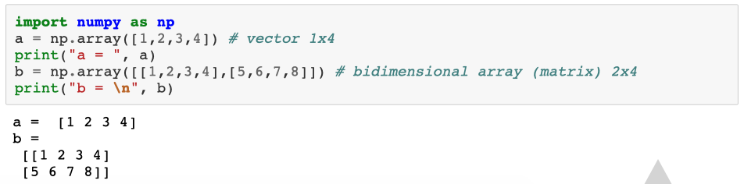

Every array has the following functions and methods available:

* 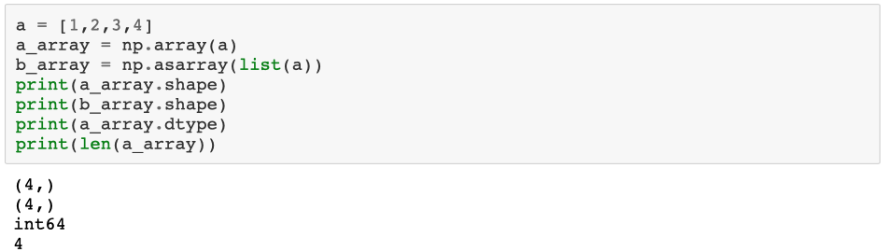array.shape : returns the dimensions of the array (a tuple of length alongside each dimension)
* array.dtype : returns the type of data inside the array (array are homogeneous)
* len(array): return the size of the **rows** (the first dimension) of a multidimensional array (the dimension over which you can loop over)

Tuple of length 1 of which the first element is 4

* np.array(list) o np.array(tuple) : convert them in a numpy array

### 

It is also possible to specify the type of numbers that the array should contain.

**NOTE**: in a numpy array all the values have the same type!

(<https://docs.scipy.org/doc/numpy/user/basics.types.html>)

Different data types can massively change the array size, and this could be a life saver when memory is limited! (sadly there is no simple way of managing 1-bit arrays for booleans)

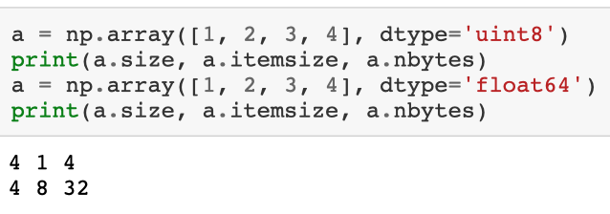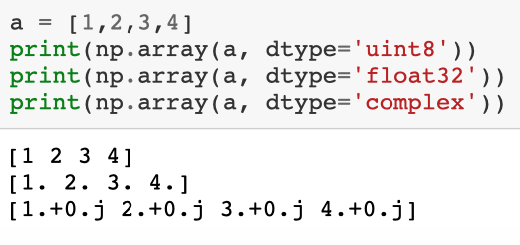

uint8 = 8 bit unsigned integer

*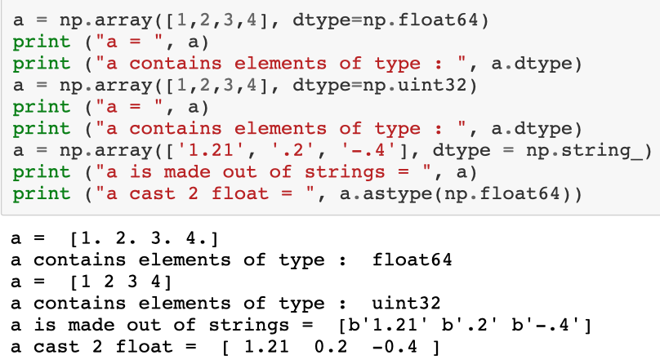TopRight*: I create a list and then I use different types for the elements of the array when I am using numpy.

*TopLeft*: I create an array and tell numpy to use a uint8. Then here I ask how many elements in the array, how much one element occupies in bytes, number of bytes occupied by the array. Storing the same elements as floating numbers implies that each element occupies 8 bytes so my same array is 8 times bigger.

*Bottom*: I can use strings as well.

### Create an array

There are 3 important functions to create an array: zeros, one and empty.

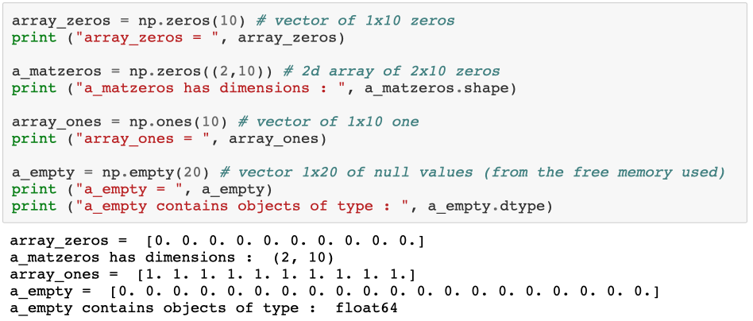

np.empty does not contains zeros, but basically random numbers. They are not properly random, but "garbage" remaining from the values of the previous of that section of memory. This is convenient when you need to write element by element, so I just reserve the space and then I initialize when I need, instead of re-initializing all to 1 or 0 first and then to the value I want.

Often you might need to create a simple array (such as ones or zeros) in the same shape as another.

**1)** A first solution might be to use the shape of the first array

a = np.array([1,2,3,4])

b = np.ones(a.shape)

print(b)

OUTPUT: [1. 1. 1. 1.]

but this looks a bit cluncky and the data type is mismatched to the original one (the original was of integers, the generated one is of float).

**2)** So a convenient set of functions are the ones_like, zeros_like, empty_like, that take the reference array as input and generate a new one with the right shape and data type

a = np.array([1,2,3,4j])

b = np.ones_like(a)

print(b)

OUTPUT: [1.+0.j 1.+0.j 1.+0.j 1.+0.j]

*Other types of initialization:*

We can create array containing numbers in a specific range

The main functions are 4: np.arange, np.linspace, np.logspace, np.geomspace

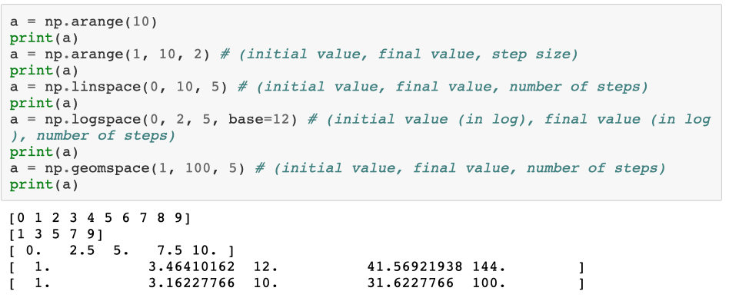

Instead of telling the log, I say the value directly.

If I do not specify the base it is base 10

start from 120 up to 122 in 5 steps.

If I do not specify the base it is base 10

arange is basically the equivalent of the range function of python

Operations between arrays and scalars

Numpy's array are not only simplifying the generation and management of data, but they have a huge number of operations that are already vectorized, such as **array-array** operations and **array-scalar** operations

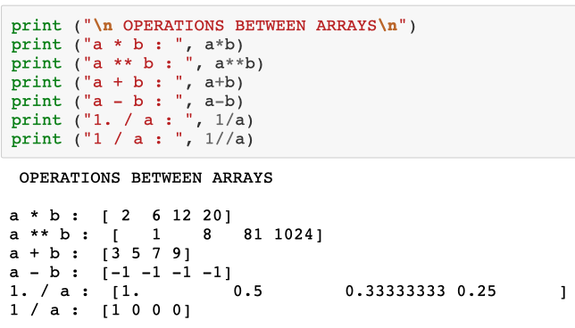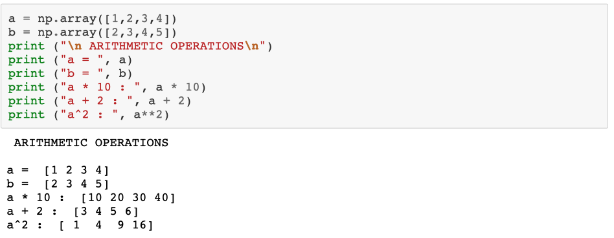

From python 3.5 a new operator has been added for vector and matrix dot product, using the @.

*Prodotto tra 2 vettori riga o colonna* *Prodotto righe per colonne*

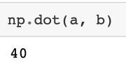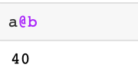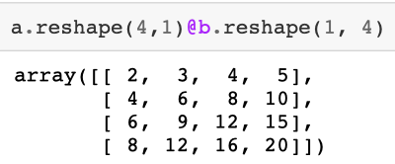

old notation new notation

Numpy supports slicing aswell (same that I used when working with lists)

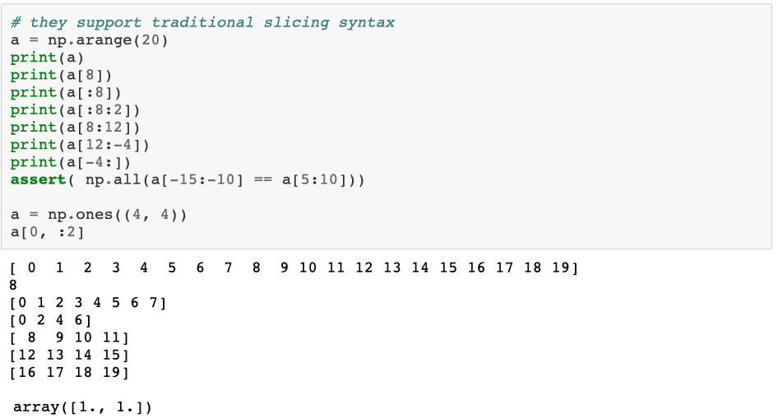

If I have several dimensions, I have to specify a slice for each dimension

When you slice an array, you don't get a copy unless you specifically ask for it with the array.copy() method. So, if you modify an element, the original array will be modified as well.

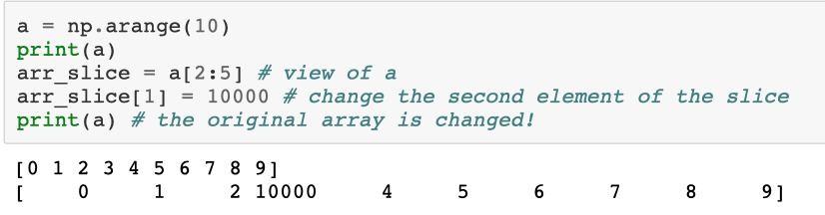

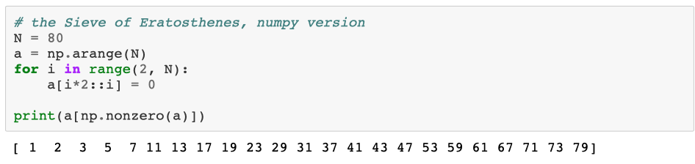Sieve of Eratosthenes = find all the prime numbers in a set of numbers.

Here I modify directly the array; I can choose what to do.

If I have several dimensions, I have a lot of freedom on how to deal with my array

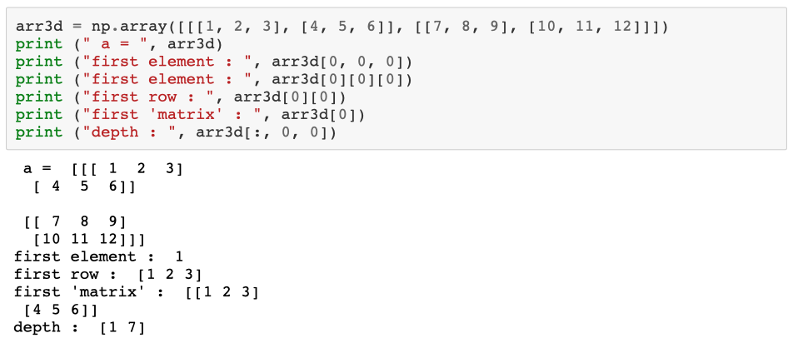

Going back to the example of the average

Let's see how much faster the numpy array can get. Numpy provides an already optimized version of the mean (as with a lot of other functions) np.mean(array)

Mean 1 = 0.49999972637047690460221360808646

Mean 2 = 0.49999972637049688861665686090419

Calculated in 7.8 sec

Mean from numpy = 0.49999972637048045731589240858739

Calculated in 0.0054 sec

The secret is that numpy is not really python so when I call a numpy function I do not have all the delays associated with the python execution.

### Random number generation

A useful practice for scientific simulations is the generation of random number. Numpy provides us with a wide range of random generators.

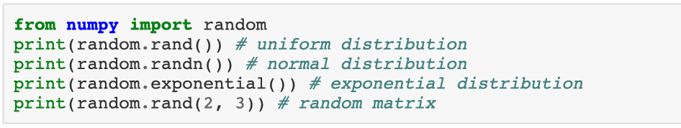

0.04188856284324605

-0.5012089524187691

0.8019130683269593

[[0.57421473 0.43093877 0.9662763 ]

[0.44139401 0.07189704 0.87782763]]

To improve replicability of random simulations it is possible to fix the **random seed**.

The seed is the first value that my random sequence starts from. Computer random sequences are not really random, but they are deterministic but really difficult to predict. Setting the seed will ensure that the random number generated are repeated exactly equally when I call two times the random generator. This is fundamental for debugging, as it allows to replicate border cases that break your code.

I set the seed by doing: np.random.seed(0)

### 

### Some useful functions

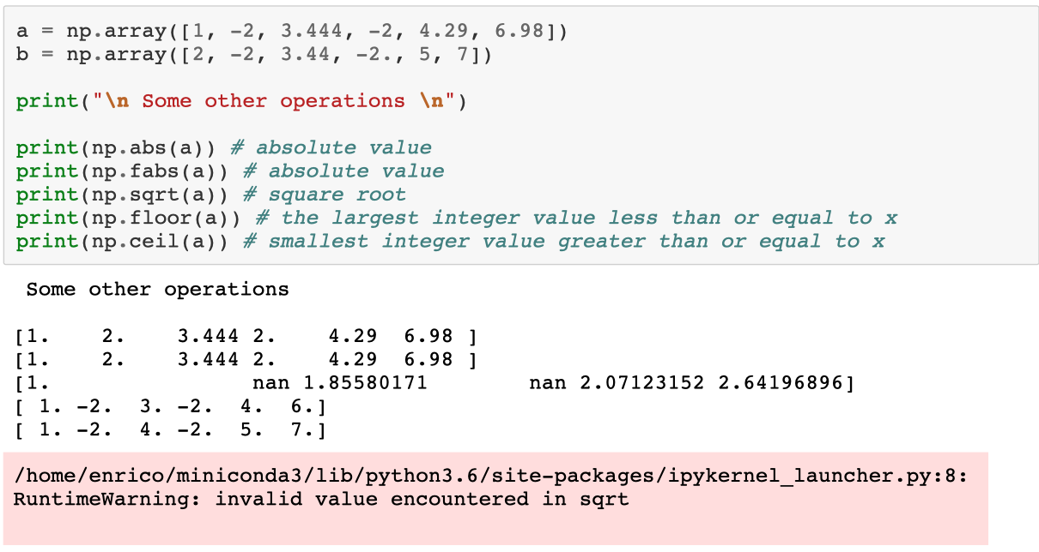

### 

### Broadcasting

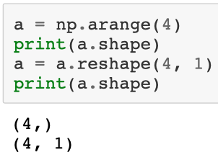Numpy can combine arrays of different sizes in a smart way, as long as they have a similar number of dimensions (or this can be padded out with sizes 1). I can reshape the array as long as the number of elements stay the same ( I can convert a 4 elements array in a 2x2 matrix, for example)

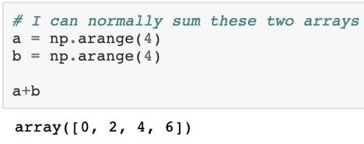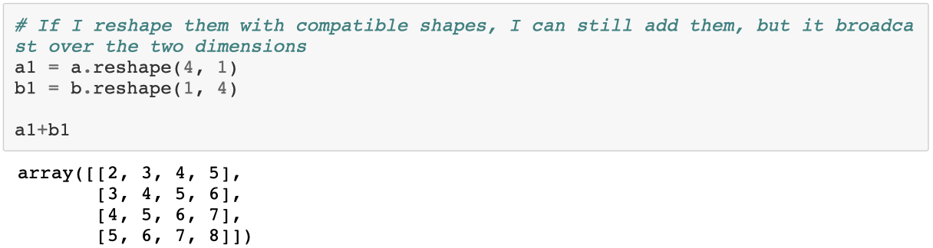

1st row: first element of a summed with all elements of b

2nd row: 2nd element of a summed with all elements of b

and so on

array([[0, 1, 2, 3],

[1, 2, 3, 4],

[2, 3, 4, 5],

[3, 4, 5, 6]])

If I reshape the arrays →

If shapes not compatible ↓

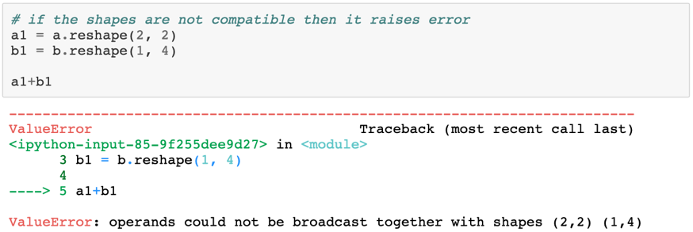

### 

### Directional application of functions

Numpy supports also the application of functions along certain axis and not only on the whole array.

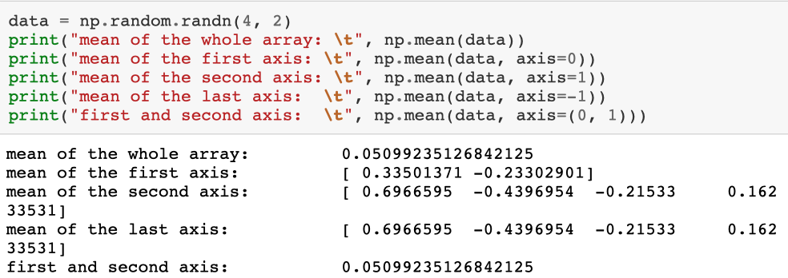For example you can ask the sum of the rows of a matrix instead of the whole sum

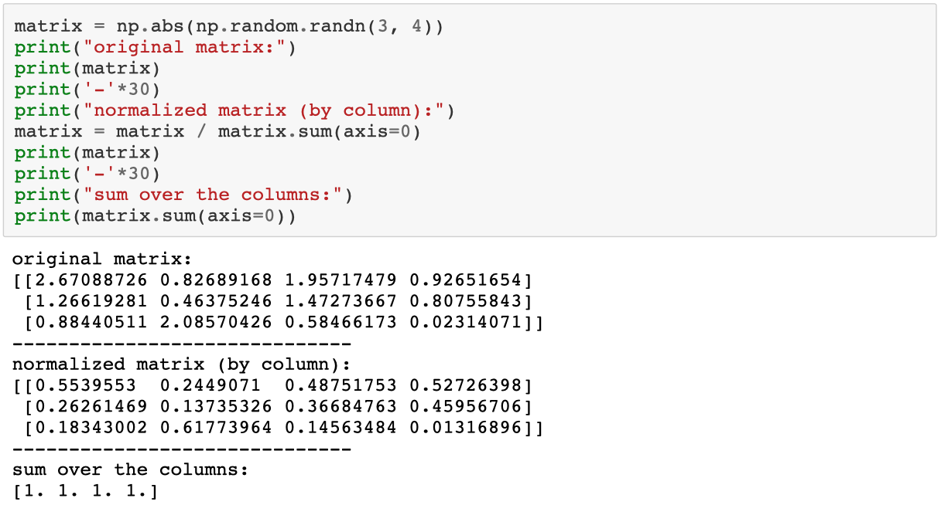

Normally these operations reduce the number of dimensions of the array.

One can also apply one of these reduction operations while keeping the same number of dimensions as the previous array, using the keepdims option.

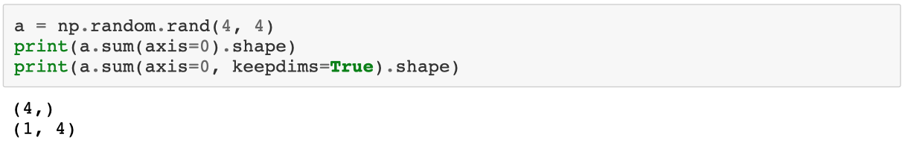

### Memory recycling

One option to optimize performance of memory use is to use an array memory space to store the result of an operation, without requiring the creation of partial results.

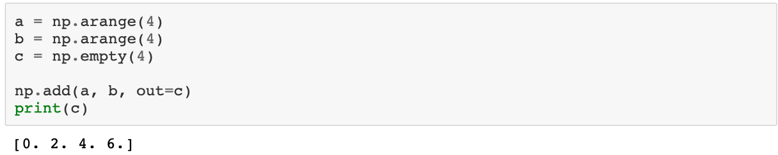

### Immagine che contiene screenshot Descrizione generata automaticamenteNumpy for scientific data

Numpy arrays are well adapted to store and manipulate scientific data, in particular **structurally omogeneous arrays.**

For example, an image is described by a 3 dimensional array: lenght, width and the 3 colors.

a fluorescence microscope might return a 6 dimensional array with dimensions for: x, y and z, colors (light field, various fluorescences), time, well of the petri.

(Even if, for this kind of structures, it might be useful to use more specialized libraries such as **xarray**).

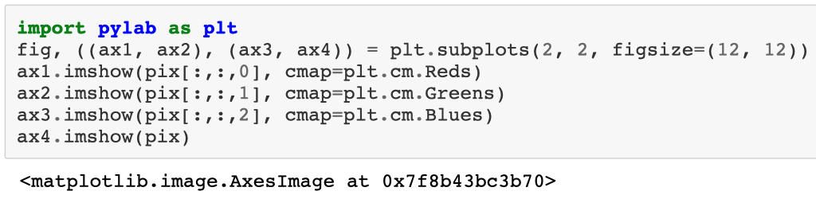

### Structured array

Numpy provides functionalities for managing tabular records of data, with the [structured array](https://docs.scipy.org/doc/numpy/user/basics.rec.html) data (and the more specialized record array).

It allows to store arbitrary tuples as items inside an array (including sub-structures or arrays)

This could be useful in some cases, but in general it would be better to use the library pandas, that we will discuss in the following lessons.

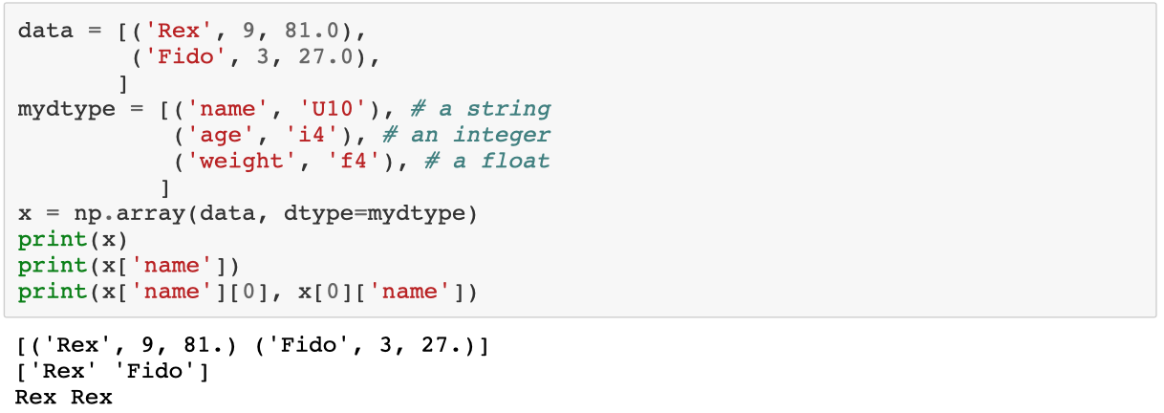

# **07_SCIENTIFIC COMPUTATION LIBRARIES**

Python provides several libraries for scientific calculations and visualization

* NumPy : the array data structure and linear algebra
* SciPy : extensive scientific computational library
* Matplotlib : data visualization

## **Scipy**

Scipy is a collection of several sub libraries that provide various capabilities:

* Clustering package (scipy.cluster)
* Constants (scipy.constants)
* Discrete Fourier transforms (scipy.fftpack)
* Integration and ODEs (scipy.integrate)
* Interpolation (scipy.interpolate)
* Input and output (scipy.io)
* Linear algebra (scipy.linalg)
* Miscellaneous routines (scipy.misc)
* Multi-dimensional image processing (scipy.ndimage)
* Orthogonal distance regression (scipy.odr)
* Optimization and Root Finding (scipy.optimize)
* Signal processing (scipy.signal)
* Sparse matrices (scipy.sparse)
* linear algebra (scipy.sparse.linalg)
* graphs routines (scipy.sparse.csgraph)
* Spatial algorithms and data structures (scipy.spatial)
* Special functions (scipy.special)
* Statistical functions (scipy.stats)

## **Matplotlib**

The first step when exploring data is to visualize them.

There are several libraries to do it, but matplotlib is the most common and is quite simple to use. Also, most libraries are based on it and knowing it can make your plots even better.

import matplotlib.pylab as plt

Examples:

* are my data really a gaussian? I can use a histogram to check that

data = np.random.randn(1000)

fig, ax = plt.subplots()

ax.hist(data)

* if I have two-dimensional data, I can easily visualize the distribution

data = np.random.randn(1000, 2)

fig, ax = plt.subplots()

ax.hist2d(data[:,0], data[:,1], bins = 30)

* or visualize the two-dim data as a scatter plot

x = np.random.randn(100)

y = x*2 + 0.1 + np.random.randn(len(x))

fig, ax = plt.subplots()

ax.scatter(x, y)

* I can also do 3D plots

**from** **mpl_toolkits.mplot3d** **import** Axes3D

**from** **matplotlib** **import** cm

**from** **matplotlib.ticker** **import** LinearLocator, FormatStrFormatter

X, Y = np.mgrid[-3:3:0.05, -3:3:0.05]*# creating a 2dim grid*

R = np.sqrt(X**2 + Y**2)

S = np.sinc(R)

fig = plt.figure()

ax = fig.gca(projection='3d')

surf = ax.plot_surface(X, Y, S, cmap=cm.coolwarm)

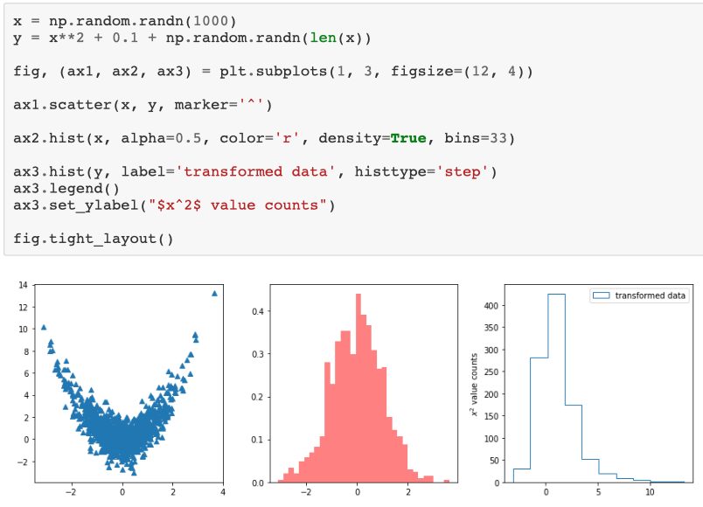

### Multiple figures and customization

Matplotlib provides support for multiple figures and strong customization of the rendered plot.

In general, it is worth investing some time to make matplotlib automatically generate the final plot instead of editing it by hand.

## **Linear Algebra – LinAlg (in scipy)**

Numpy already provides several linear algebra functionality; scipy expands on that.

The basic operation for linear algebra is the scalar product between two arrays. I can obtain it using the np.dot function, or the @ operator.

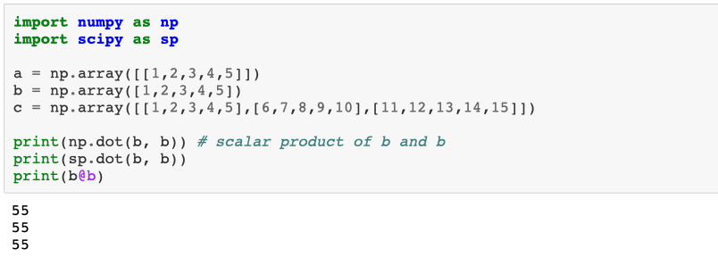

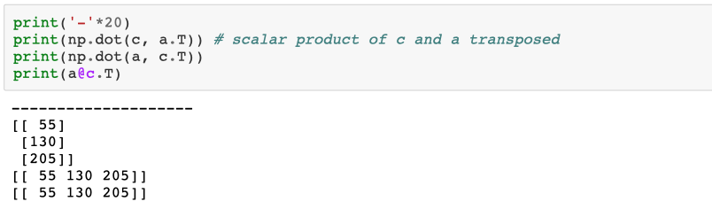

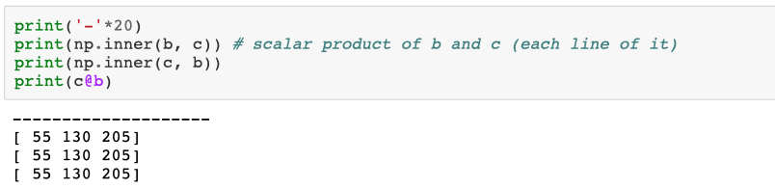

### Eigenvalues and eigenvectors

To compute the eigenvalues and eigenvectors of a matrix I can use the np.linalg.eig function

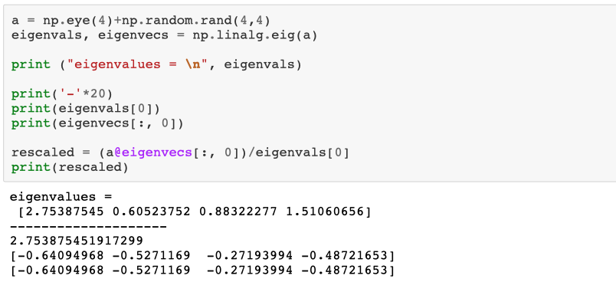Often one does not need all the eigenvectors or eigenvalues. Usually one only needs the biggest or the smallest. There are algorithms that allow to evaluate only those, particularly useful for sparse matrices.

How these eigenvalues are selected is controlled by the which parameter:

* 'LM': largest magnitude (default)
* 'SM': smallest magnitude
* 'LR': largest real part
* 'SR': smallest real part
* 'LI': largest imaginary part
* 'SI': smallest imaginary part

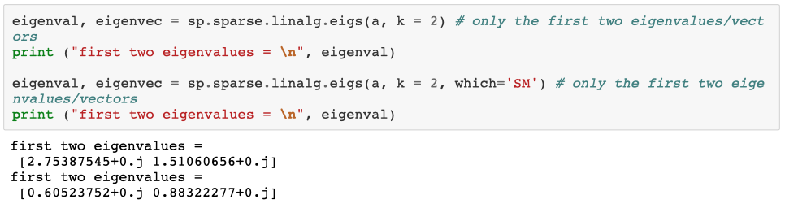

## **Sympy**

While not part of scipy, there is a library worth mentioning for symbolic calculus: sympy.

It will allow you to define symbols and manipulate them in a way closer to what one would do while doing math.

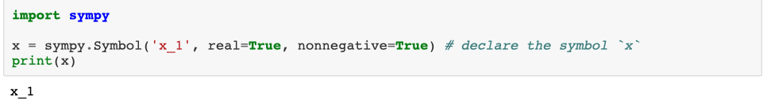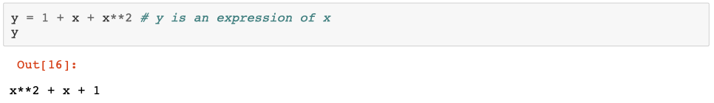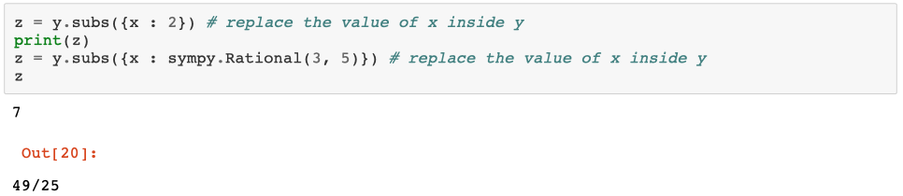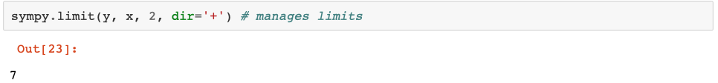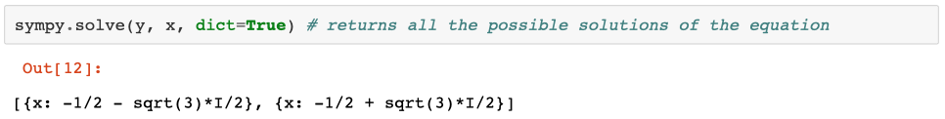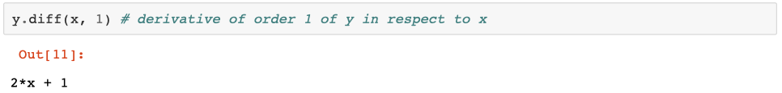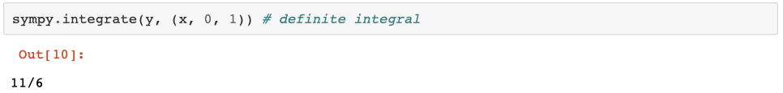

## **Differential equations (in scipy)**

Another important topic is the differential equation integration.

There are several ways of solving them, more or less accurate (Euler, RK2, RK4, RK45).

Scipy provides us with a unified interface for this under the scipy.integrate module, and the odeintfunction.

from scipy.integrate import odeint

Example: $\dot{y}= -αy$ with starting point $y(0) =y_{0}$ has a solution with an exponential decay

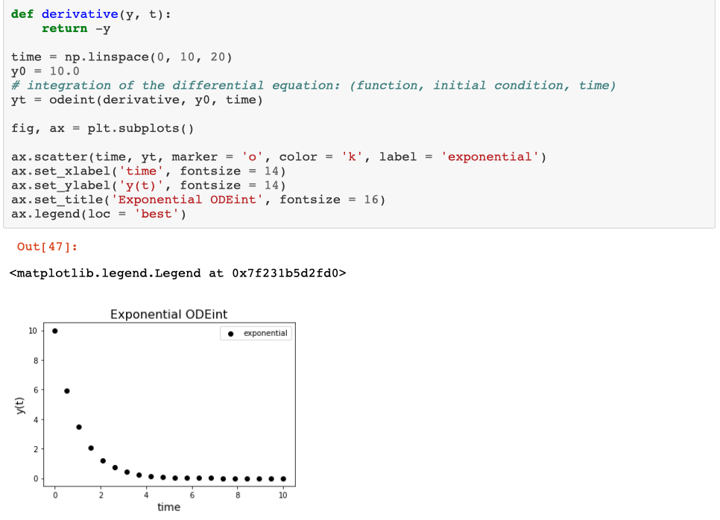

## **Fitting of a curve (in scipy)**

Let's suppose that we want to fit some noisy data that came from an exponential curve (like the one we evaluated earlier, see plot on the right).

This fit can be done using the curve_fit function from the scipy.optimize module.

we need to pass it the complete function that we want to integrate.

from scipy.optimize

import curve_fit

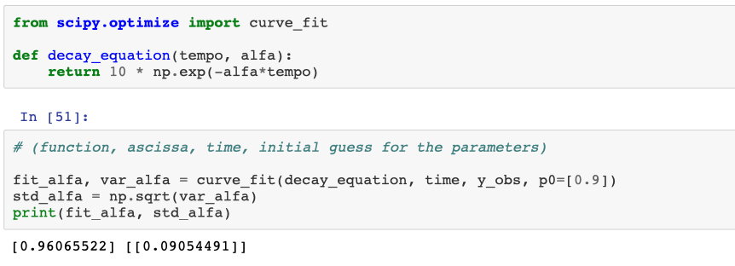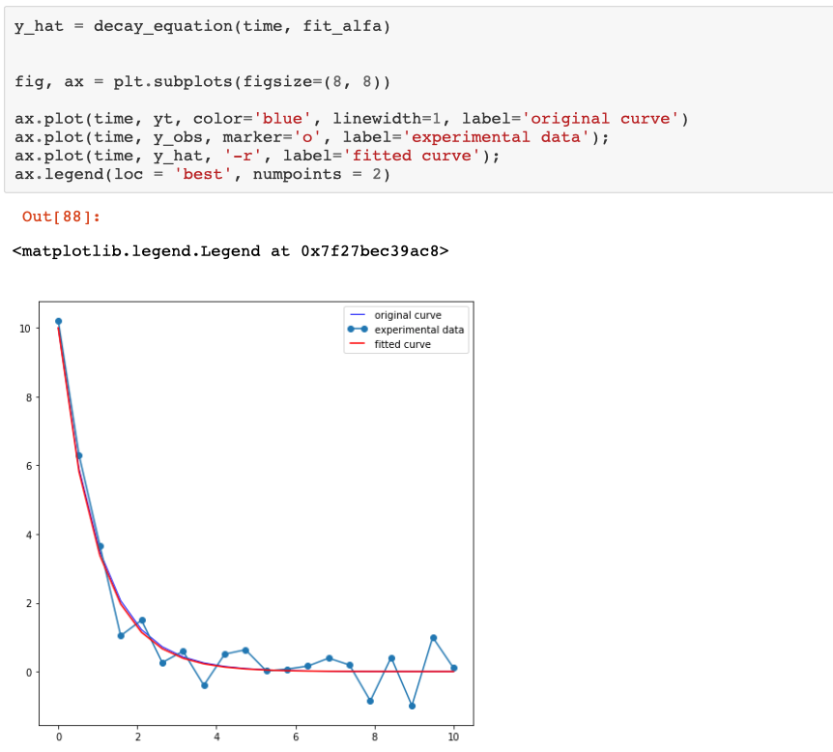

## **Metropolis Algorithm**

Algorithm that can be used to estimate the integral of a function using a Monte-Carlo evaluation. In this case we will use it to estimate the value of 𝜋.

We can consider a circle of radius 1, centered in the origin. This circle has an area of 𝜋. Let's imagine a square inscribing it, centered in the origin as well. This square has a side of 2, with an area of 4.

If we extract numbers on the plane in the interval 𝑥∈[−1,1] and 𝑦∈[−1,1] the point will be inside the circle if 𝑥2+𝑦2<1 and will be considered a hit.

After a huge number of points, we have that the fraction of points inside the circle should be proportional to the ratio of the area of the circle and the area of the square. the numbers of hits will therefore be: 𝐻𝑖𝑡/𝑇𝑜𝑡=𝜋/4

You can repeat the simulation N_runs times to estimate the precision of your estimate of 𝜋.

The following is a very long and slow implementation, can you do better using numpy?

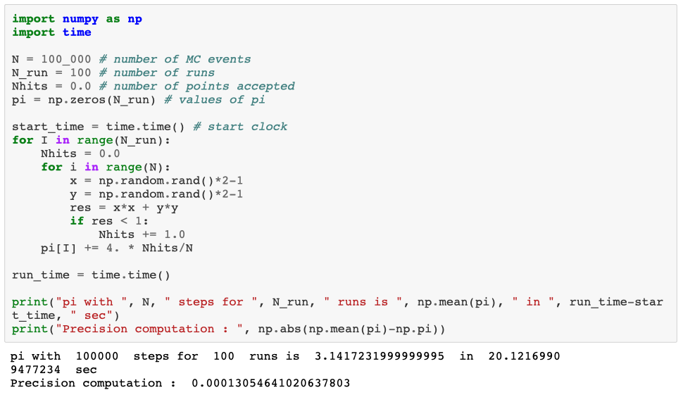

# **08_DATA PIPELINE AND SNAKEMAKE**

Today we discuss how to structure a data analysis pipeline, which is the logic of it, how to manage data and automate the analysis with **workflow management tools**; in particular, the one we are going to use is called **snakemake.**

Coming back to the previous lessons about analysis reliability and reproducibility: *anything you do by hand is to be consider already forgotten. You have to automate it as soon as possible.*

This automation can be done at several levels:

* do not manually change the data
* do not throw away the results of the analysis
* do not check them just with your eyes
* manually join the various steps of the analysis

In an ideal world, all the analysis and preliminary reports should be done with a single push of the button.

## **Data types**

Data can be usually distinguished in two main types: text data and binary data

### Text data

These data are nothing more than text files where the data are formatted in a way that makes them understandable by a computer as well as readable by a human being.

These are usually expensive in terms of disk space and read/write time but are also more robust to data corruption and can be easily inspected and audited by a human being.

These formats are often compressed to save disk space and bandwidth, and should formally be considered binary formats, but given that many libraries are able to read them both compressed and uncompressed, I will pretend that there is no difference.

#### CSV and TSV

These formats are used to store tabular data, storing the table line by line, where each line is separated by a comma (**Comma Separated Values**) or tab characters (**Tab Separated Values**).

One might find several variations of this format, for example dividing data using | or ; and whether text data contained in a cell is surrounded by "" or not.

name;age;residency

Antonio;32;Bologna

Maria;25;Torino

Francesco;47;Napoli

Many variants consider the # character at the beginning of the line to be a comment.

They can be easily opened with programs such as Microsoft Excel or OpenOffice Calc, but they are limited in storing only tabular formats.

#### JSON

A standardized exchange format on the web, it is very useful to represent hierarchical data. It can roughly be thought as a text equivalent of a dictionary containing numbers, string, lists or other dictionaries. It is white space insensitive.

{"people":

{"antonio":

{"age": "32", "residency": "Bologna"},

"maria":

{"age": "20", "residency": "Cesena"},

}

}

#### JSON lines

[JSON lines](http://jsonlines.org/) is a recently proposed merge between **csv** and **json**, where each line is a valid json list, but the whole structure represents a tabular dataset.

The advantage is that standard json parsers can be used to manage these files, simplifying the interoperability across systems (which is often a problem with the **csv** format, that does not have a formal specification)

["Name", "Session", "Score", "Completed"]

["Gilbert", "2013", 24, true]

["Alexa", "2013", 29, true]

["May", "2012B", 14, false]

["Deloise", "2012A", 19, true]

#### INI

INI were designed under Microsoft Windows as configuration files, and have become a very common format to include this kind of information (including in python). They a syntax and expressiveness similar to JSON, but several simplifications

[Section]

key_with_value = 2

boolean_toggle_key

[subsection]

sub_detail = 3

[New section]

another_parameter = "hash code"

#### YAML

YAML is another configuration format. It's quite rich and easy to write and parse for humans, but it's a format so rich and potentially complicated that there is no actually guarantee that any library can successfully import your data if the format is very complicated.

It's quite comfortable to use if you don't need very complicated data.

people:

Antonio:

age: 30

residency: Ferrara

hobby: [fishing, football]

Maria:

age: 20

residency: Torino

hobby: [snorkeling, skydiving

#### XML

This format is an evolution of the original XML, and is well suited to represent very complicated and interconnected data (could replace an entire database), but it is extremely verbose and parsing it can be non-trivial if there is no specification of its structure.

a lot of "regular" formats are actually XML under the hood:

* svg vector images
* openoffice and office documents (compressed xml)
* many html pages
* several specialistic formats in various fields

<peoplelist>

<person name='Antonio'>

<birthyear>1983</birthyear>

<townofresidency>Bologna</townofresidency>

<hobbies>

<fishing/>

<football/>

</hobbies>

</person>

<person name='Maria'>

<birthyear>1997</birthyear>

<townofresidency>Rimini</townofresidency>

<hobbies>

<snorkling/>

<skydiving/>

</hobbies>

</person>

</peoplelist>

### Binary formats

# **09_DATAFRAMES IN PANDAS**

Dataframe are a data structure equivalent to individual tables in a database.

Nowadays every high level programming language has its own implementation of the same concept A dataframe is a table, indicized with rows and columns.

Imagine a table containing information about people:

* each row represents a person and is uniquely associated to the by the row index
* each column represents something measured about that person

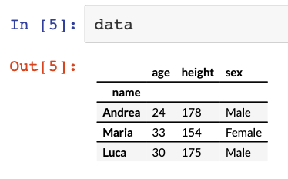

[python: Pandas DataFrames](http://pandas.pydata.org/)

[**R: dataframes**](https://en.wikibooks.org/wiki/R_Programming/Working_with_data_frames)

[**Matlab: Table**](http://blogs.mathworks.com/loren/2013/09/10/introduction-to-the-new-matlab-data-types-in-r2013b/)

[**Julia: DataFrames**](https://en.wikibooks.org/wiki/Introducing_Julia/DataFrames)

## **Tidy Data**

Dataframes allow us to collect and manipulate informations in a very comfortable way, and are the central pillar of modern data analysis.

A special role is played by the data that are organized as **TIDY DATA**, term introduced in the community by Wickham in 2010 in his [seminal paper](http://vita.had.co.nz/papers/tidy-data.pdf).

Tidy data is a way of structuring your data that makes analysis, visualization and data maitenance particularly easy. It is a simplified form of **database normalization**, a series of principles on how to design a good database.

A tidy dataframe is defined as having the following properties:

* a table represent a single set of measurements
* every measured variable is represented by a column, and contains a single, well defined measurement
* every observed unit is represented by a row

where:

* observation: the physiological informations about a person
* observations units: each person
* variables: age, sex, height, etc...

An experiment will provide several tidy table (a database), connected logically one to the other.

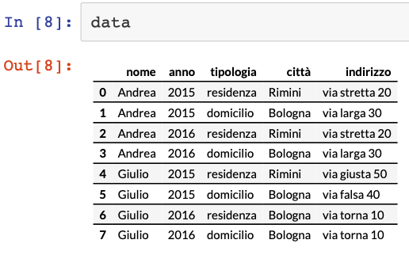

The important thing to remember with this type of data is that this might not be the ideal format for the analysis you have in mind.

The tidy format is brilliant, especially for long term storage and to keep the metadata about the measurements, but some analysis might need the data to be transformed in non-tidy formats (for example to evaluate differences in various time points)

For this reason, all the libraries that manage datafarme havea strong focus on data transformation, reshaping the data from one form to the other. This allows to easily obtain the best structure for the analysis we want to do without sacrificing the data quality in long term storage.

## **Introduction to Pandas**

**Pandas** is the main library in python that allows one to manipulate dataframe structures.

The library introduces the class **DataFrame**, that holds a single table made out of various **Series**, that represent each column, all sharing the same index.

One of the strenghts of pandas is the ability to read and write almost any tabular format.

For example we can download and parse tables from a wikipedia page with a single command

We will discuss:

* reading and preprocessing the dataframe
* performing selections on it
* dataframe manipulation:
  + groupby
  + joins
  + pivoting
* simple visualization
* advanced visualization

We will take a Wikipedia page as an example

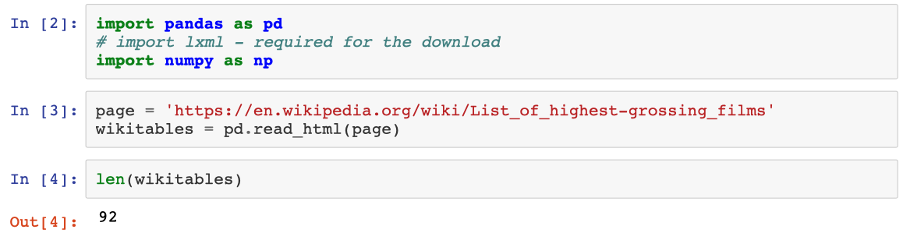

The page contains several tables, and we obtain a list with all of them.

The one we are interested about is the first one, the proper table of the highest grossing movies.

Reading functions contain tens of parameters to allow us to read the data exactly as we need them.

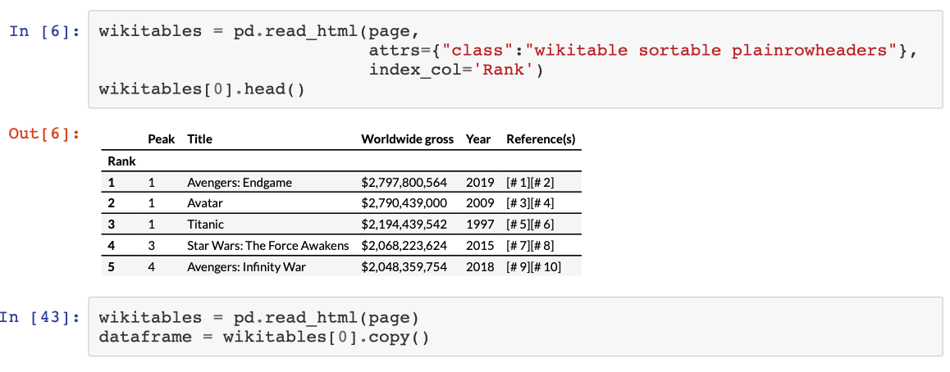

The dataframe behave similarly to a dictionary.

The column names are the Keys, and the values are the Series associated with those names

### Series

Series behaves similarly to numpy array in regards to vectorization, but they join values based on the index and not the order of the elements.

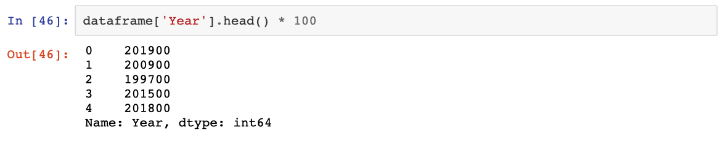

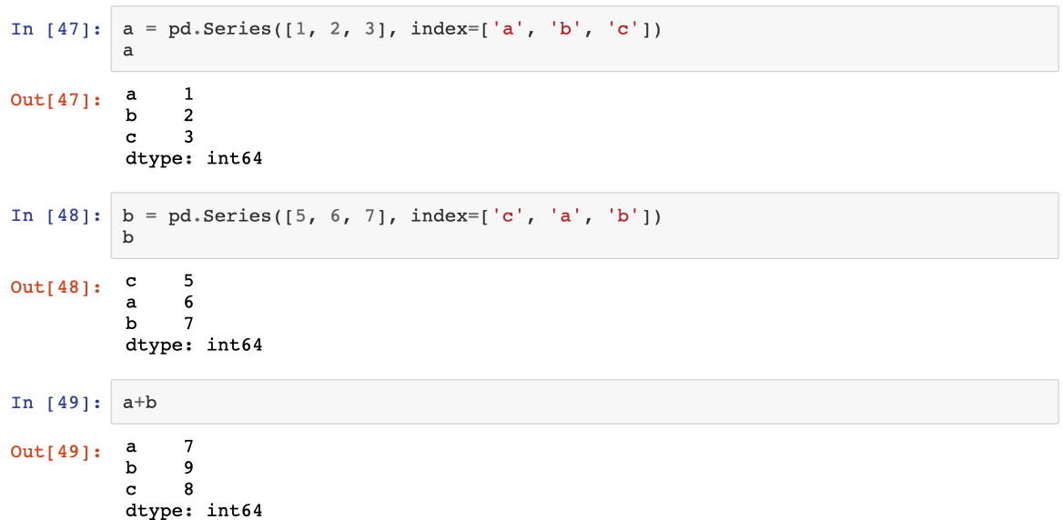

Series and DataFrames inherit also the slicing properties of numpy arrays.

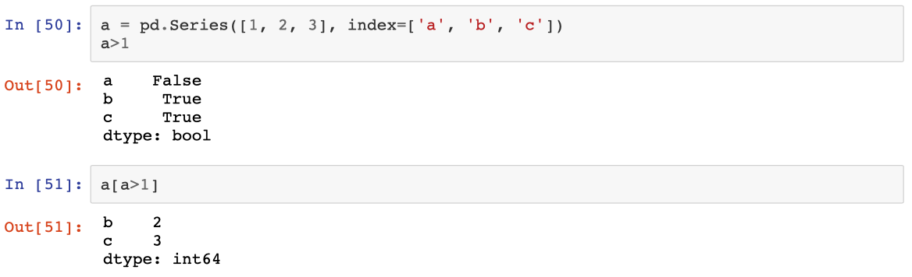

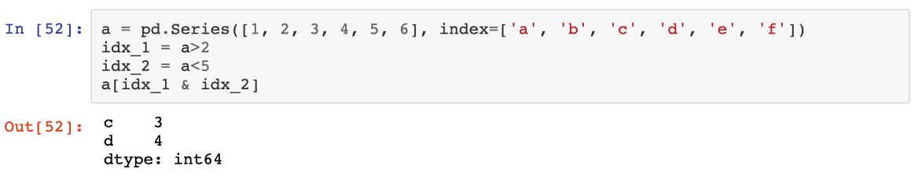

They can be sliced on the index as well, both by single keys and range of keys.

the range of keys are referred to the order of the index, not the natural sorting of the values contained in it.

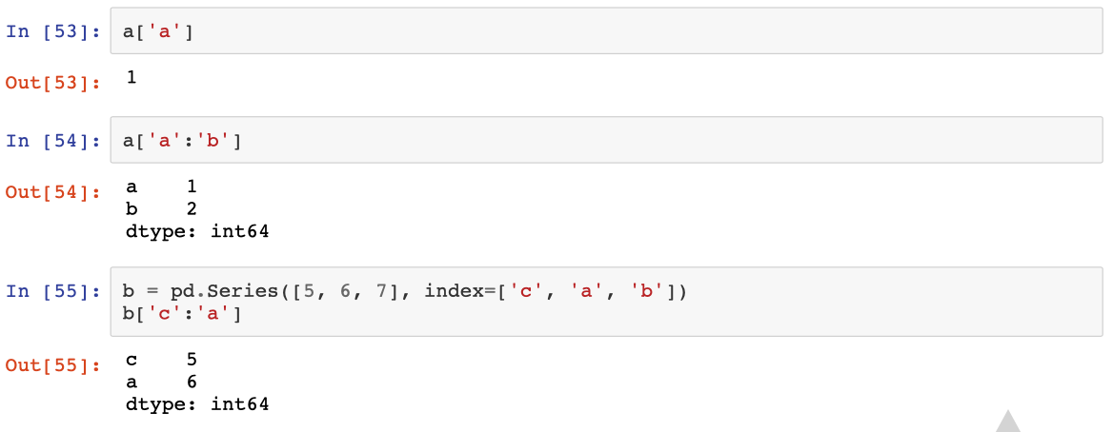

### Series as elements of a DataFrame

I can manipulate columns in various ways, starting from the possibility of removing unwanted ones.

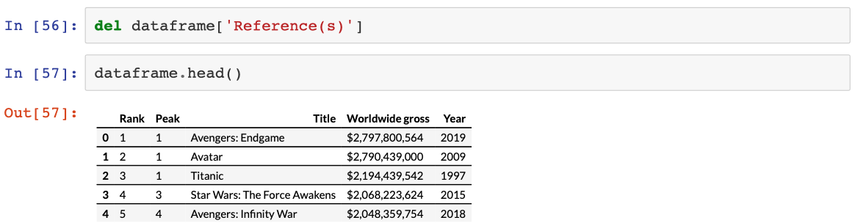

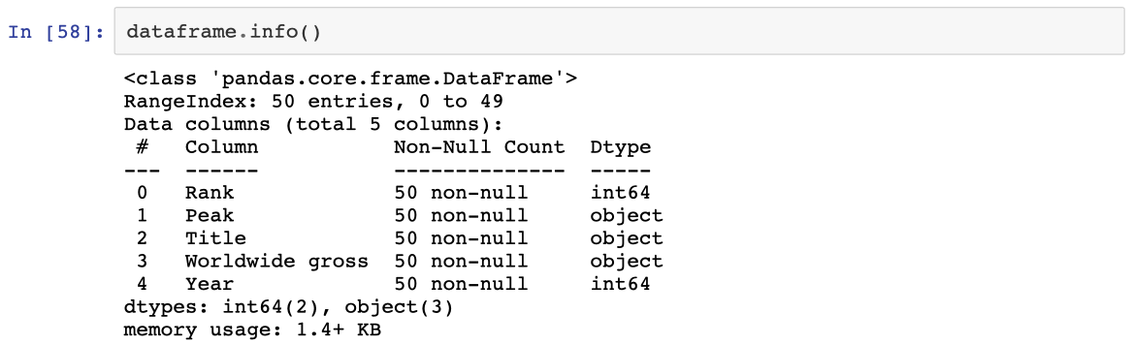

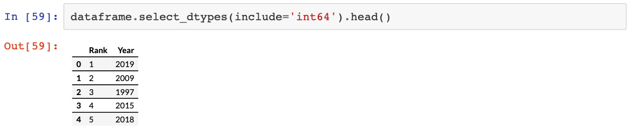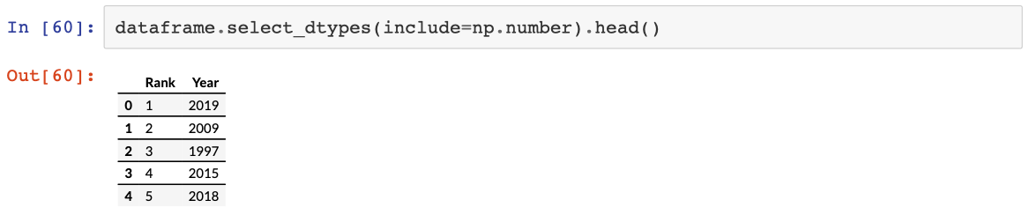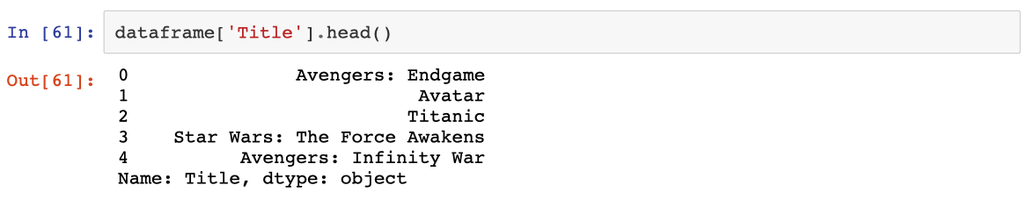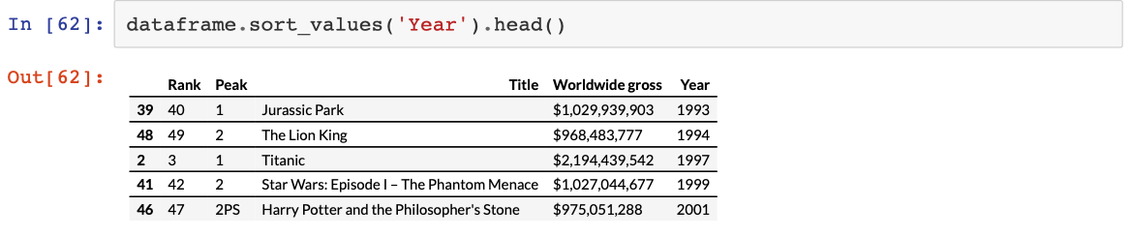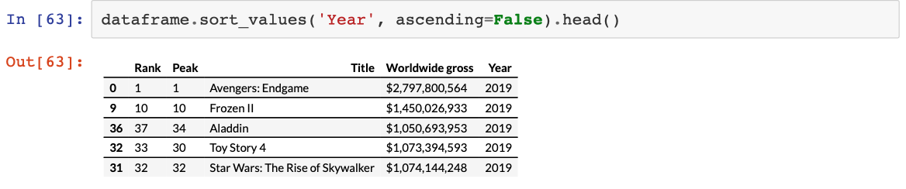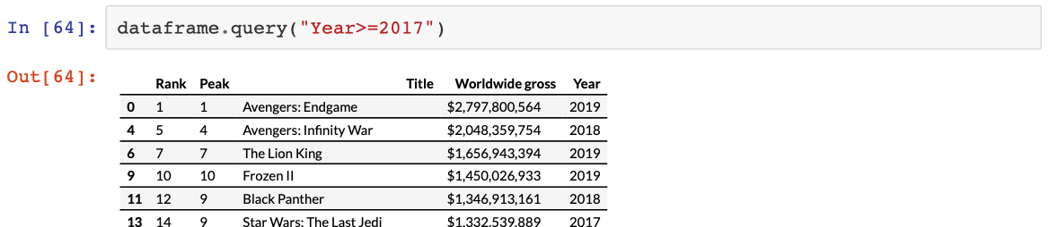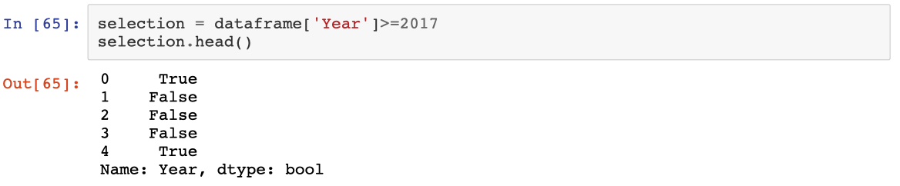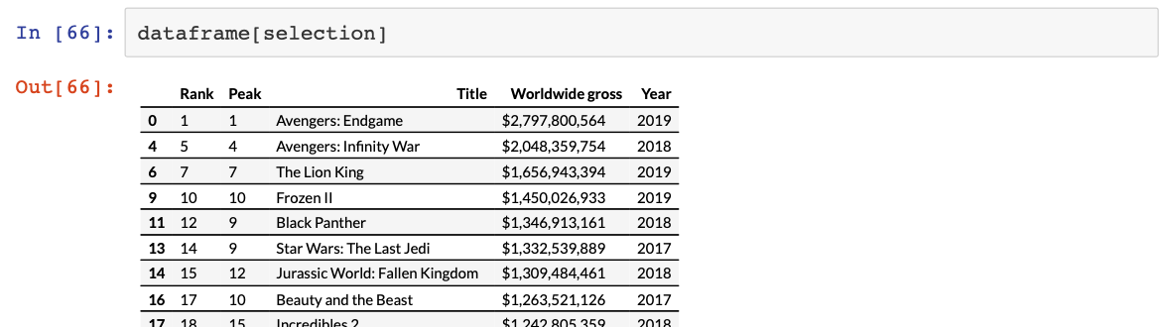

## Dataframe manipulation

Often real data arrives in a format that can only be defined as "far from optimal"

The first (and major) part of data analysis is data cleaning and preprocessing in a decent form

In our case, for example, we might need to adjust the earning of each movies, as we would like to treat them as a number and not strings.

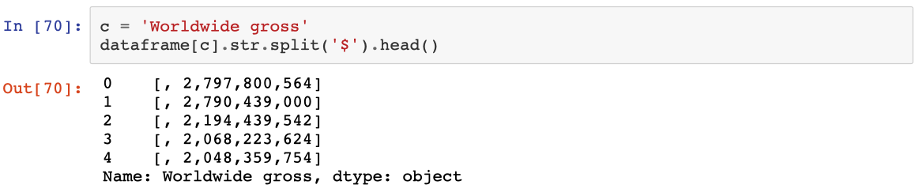

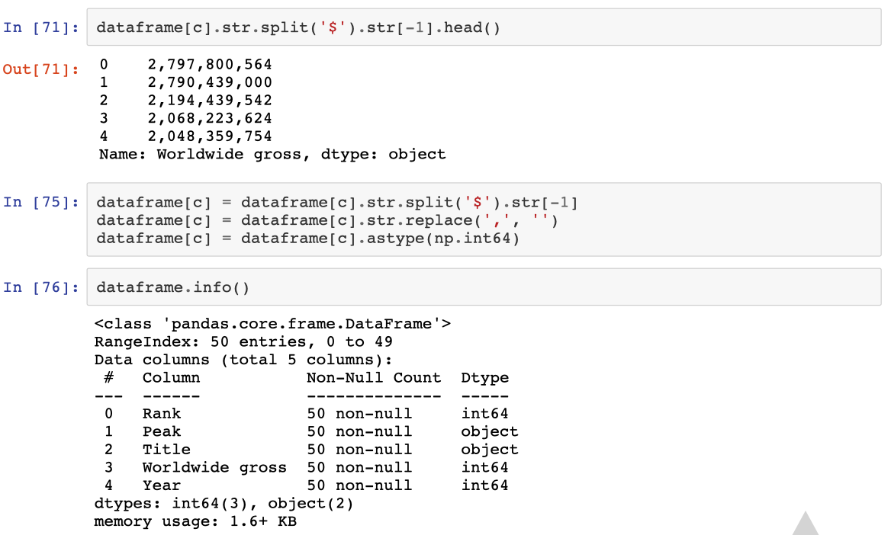

Sometimes, one needs to use some violence...

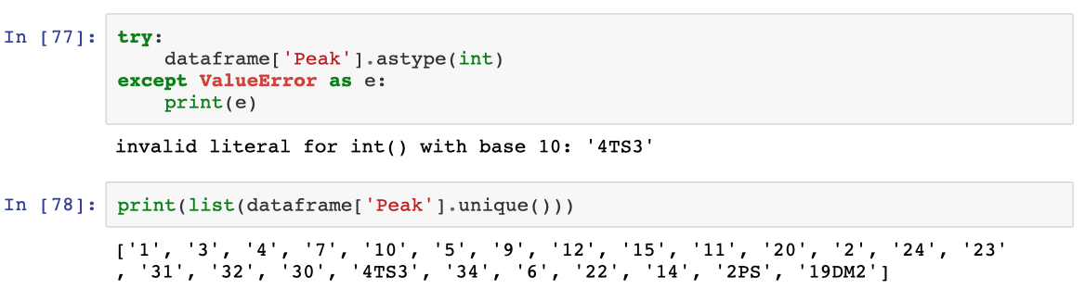

Given that there is no simple transformation, we need to use **regular expressions**.

regular expression are a way to express text structure and to specify which part to extract from it

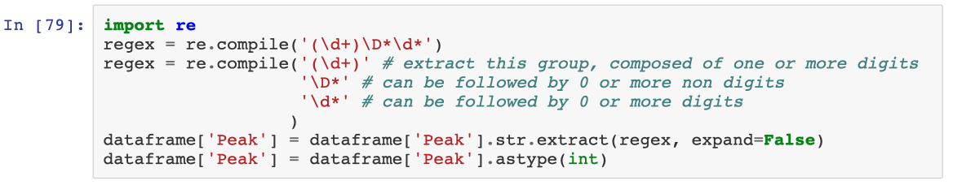

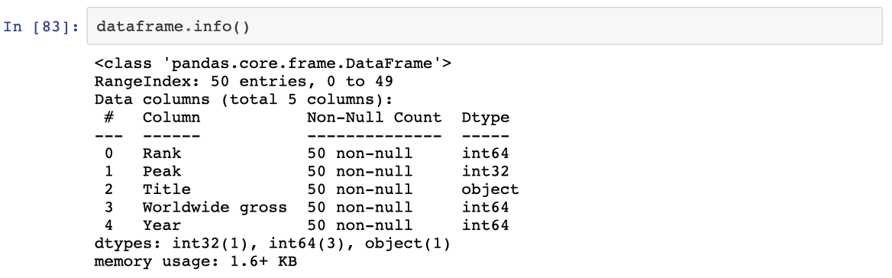

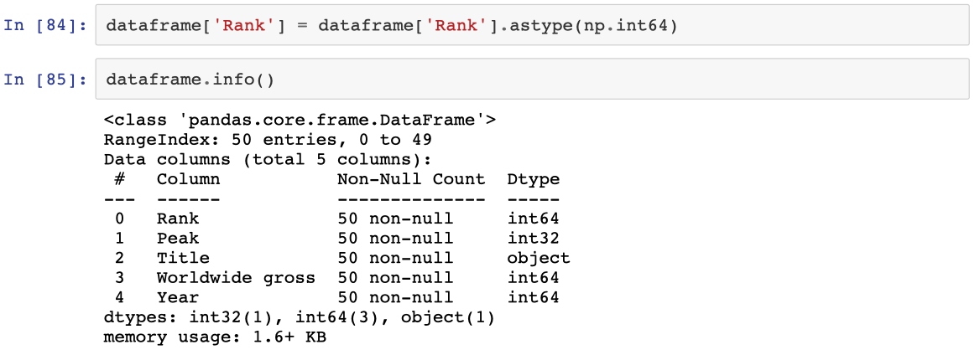

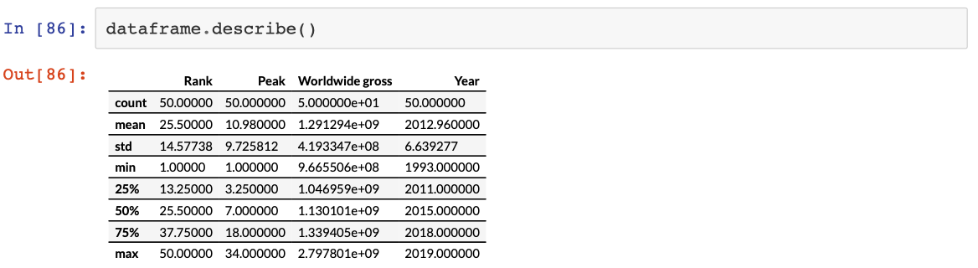

## DataFrame visualization

We can do it with both matplotlib and pandas.

both have special methods to display the data contained in a dataframe.

Later on we will see a more appropriate library, **seaborn**, but for now we will use a *quick & dirty* approach. **import** **pylab** **as** **plt**

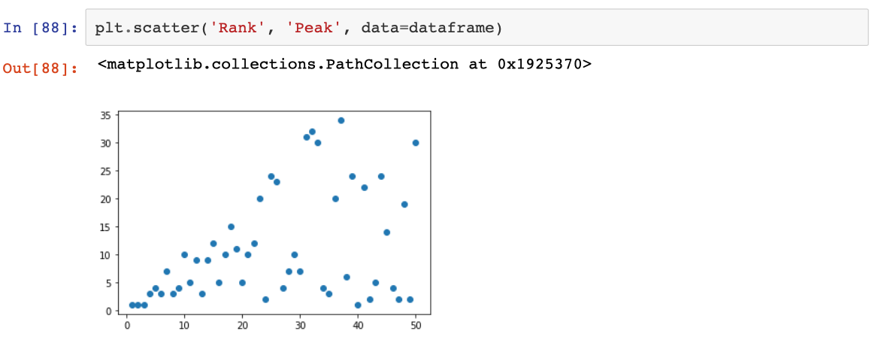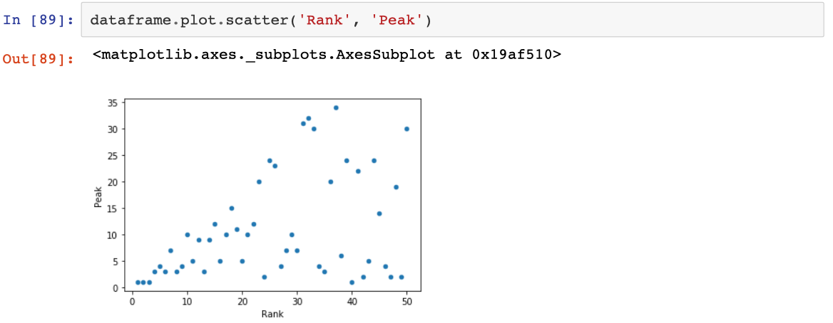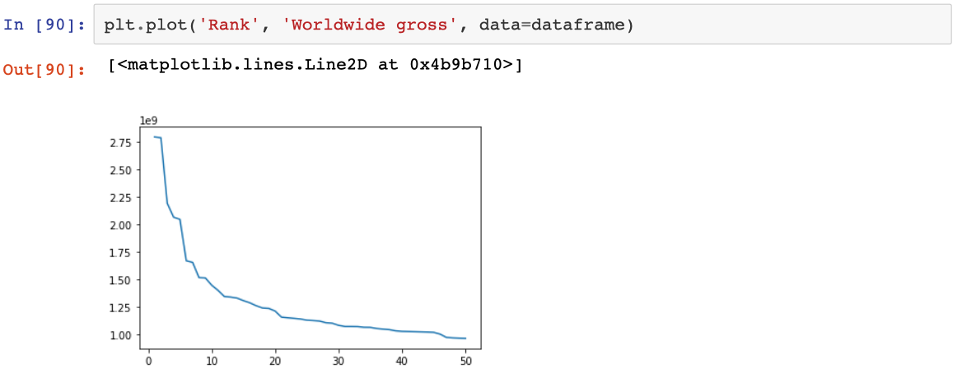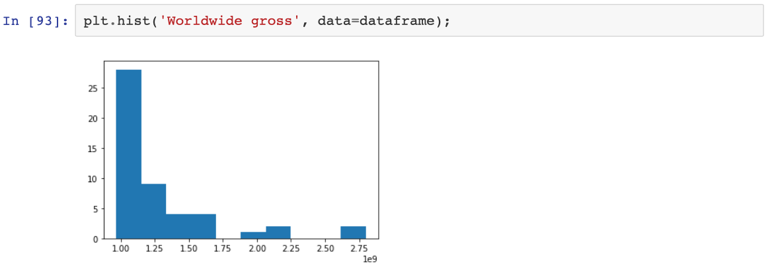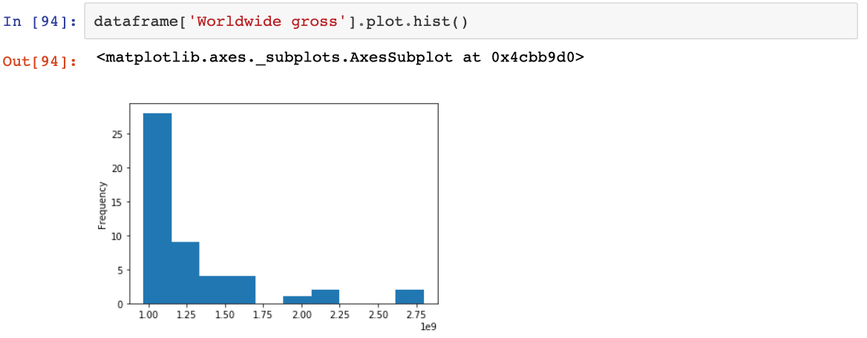

# **10_OBJECT ORIENTED PROGRAMMING IN PYTHON**

How to develop libraries and program with human API